**PROJECT REPORT**

**Naan Mudhalvan – Salesforce Developer**

**Project Title:** **Workforce Administration Solution**

**Team Members:**

|  |  |  |
| --- | --- | --- |
| **Name** | **NM user name** | **32 digit NM ID** |
| Sivakkumaran P(T.L) | aut7100TRCSE001 | 2964B3D68EE3254A679444119B3C3D5B |
| Devadharshini M | au710021104006 | CFFBCE3509ECDA68C23419074440C34F |
| Rinisha G | au710021104023 | 9D323F82AF890C799EE4CC2430EE888D |
| Tamilvanan V M | aut710021104322 | 3837B5DC5E49A11B7284114FC2485850 |
| Jelin Ranjitha K | auttrcse005 | 0DDCAC72DDDAC0796484F02653B520DE |



**ANNA UNIVERSITY**

**REGIONAL CAMPUS COIMBATORE**

**Workforce Administration Solution**

**Project Description:**

Workforce Administration Solution is a software application or platform designed to streamline and automate various aspects of employee’s working on projects and Asset Assignment processes within an organization. It serves as a centralized system for managing employee data, number of projects an employee is working on, tracking employee performance, and keeping record for the assets which they are assigned to.

**Short Description:**

Workforce Administration Solution automates employee project work and asset assignments, centralizing data management, project tracking, and performance monitoring within organizations.

**Introduction:**

**Workforce Administration Solution** is created in companies to streamline and automate various aspects of employee management, project tracking, and asset assignments. Key purposes include:

1. **Centralized Data Management**: Consolidates all employee, project, and asset data into a single platform, making it easier to manage and access essential information.
2. **Project Tracking**: Monitors employee involvement in projects, tracks project progress, and organizes task assignments, enabling efficient management and productivity insights.
3. **Asset Management**: Keeps records of assets assigned to employees, ensuring accountability and facilitating better asset utilization and tracking.
4. **Enhanced Security and Compliance**: Ensures sensitive data security with access restrictions, secure storage, and compliance with data protection policies, especially using Salesforce’s cloud capabilities.
5. **Performance Monitoring**: Allows companies to assess employee performance, providing insights for workforce planning and optimizing resource allocation.
6. **Automated Administrative Processes**: Reduces manual tasks for HR and admin departments, such as employee onboarding, project assignments, and leave approvals, boosting efficiency and reducing errors.

By implementing a Workforce Administration Solution, companies can improve operational efficiency, strengthen data security, and support strategic decision-making based on reliable and organized information.

**Technical Architecture:**

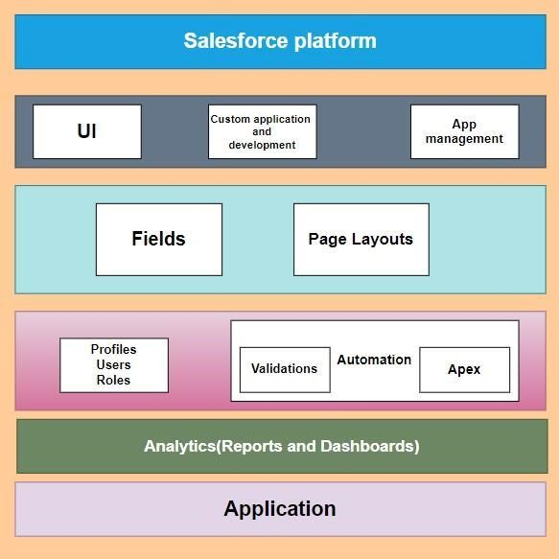

**Project Flow:**

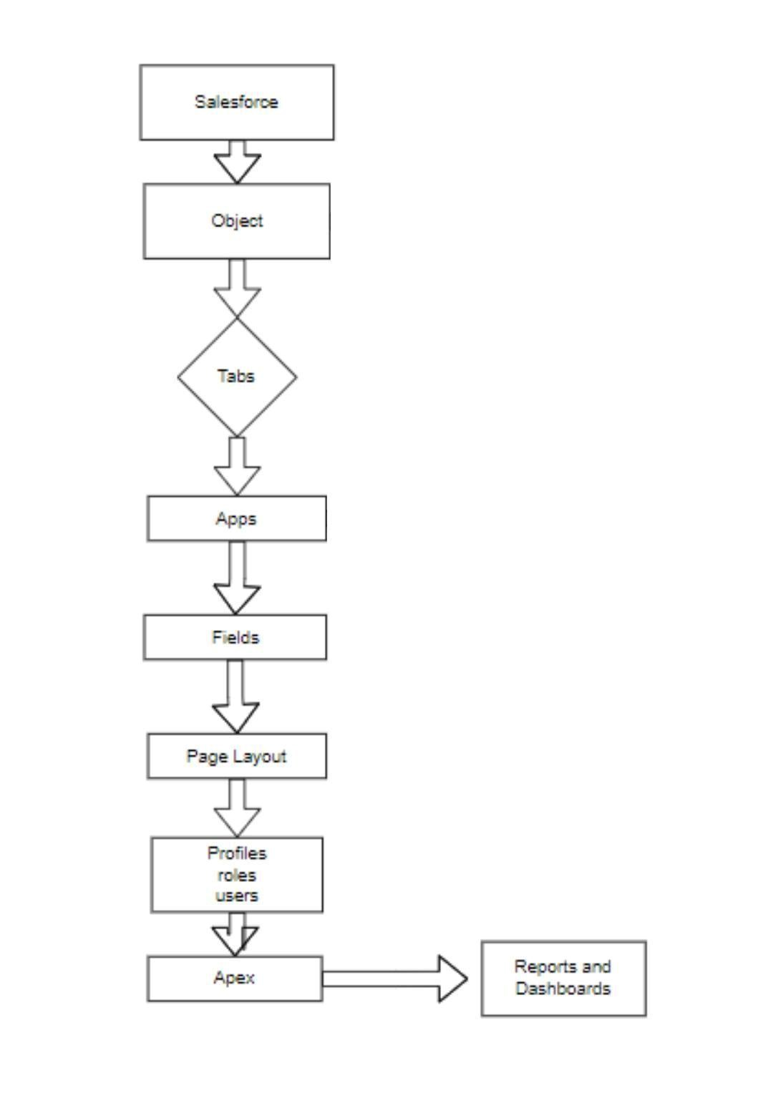

**System Requirements:**

Windows 11

Install with two web browser

Bandwidth of 30mbps

**What we learnt**

1. Real Time Salesforce Project
2. Data Modelling
3. Creating an Application
4. User Interface Customization
5. Importing bulk amounts of data
6. Security in Salesforce
7. Group Collaboration
8. Reports & Dashboards

**Use Case:**

In an effort to enhance data security and performance while simplifying system administration, TheSmartBridge company is transitioning to Salesforce, a new cloud technology. By leveraging this advanced platform, the company can ensure the safe storage of sensitive data through robust encryption and proactive backup mechanisms. The cloud's automated data replication capabilities provide added protection and efficient disaster recovery solutions. With access to scalable resources, TheSmartBridge can optimize performance, ensuring fast and reliable access to data. This shift to the new cloud technology streamlines administrative tasks, reducing complexity and allowing system administrators to focus on higher-value activities, ultimately increasing productivity and enhancing overall operational efficiency.

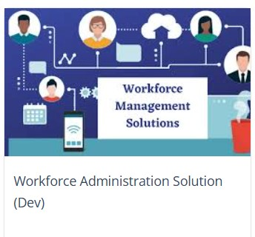

# Milestone 1-Salesforce

**Introduction:**

Salesforce is a leading cloud-based platform that provides customer relationship management (CRM) solutions, helping businesses streamline and automate interactions with customers, sales, and support. Founded in 1999, Salesforce enables companies to store customer data, manage sales, and create personalized marketing campaigns. It includes various tools for sales automation, customer service, marketing, and analytics, all accessible through a single, customizable interface.

One of Salesforce’s standout features is its flexibility; it offers options to build custom applications, integrate with external systems, and extend functionality with third-party apps from its AppExchange marketplace. With robust security, scalability, and AI-driven insights (such as through Salesforce Einstein), the platform empowers organizations of all sizes to improve productivity, make data-driven decisions, and enhance customer satisfaction.

**What Is Salesforce?**

Salesforce is your customer success platform, designed to help you sell, service, market, analyze, and connect with your customers.

Salesforce has everything you need to run your business from anywhere. Using standard products and features, you can manage relationships with prospects and customers, collaborate and engage with employees and partners, and store your data securely in the cloud.

So what does that really mean? Well, before Salesforce, your contacts, emails, follow-up tasks, and prospective deals might have been organized something like this:

<https://youtu.be/r9EX3lGde5k>

**Use Case:**

Creating a Salesforce Developer Edition org allows developers to experiment, innovate, and build customized solutions within a controlled environment. With access to Salesforce's powerful development tools and features, developers can prototype, test, and refine their applications, empowering them to deliver robust and tailored solutions to meet unique business requirements. As a Salesforce Administrator for TheSmartBridge you must have a Salesforce developer edition org in order to do all the required works which the CEO desires for TheSmartBridge.

Before creating our developer account, we must know what are the types of Editions

Salesforce offers.

**Types of Salesforce Editions:**

|  |  |  |
| --- | --- | --- |
| 1 | Essentials | Designed for small businesses getting started with CRM to boost sales or service productivity. It includes a setup assistant and administration tools to customize your deployment as you grow. |
| 2 | Professional | Designed for businesses requiring full-featured CRM functionality. It includes straightforward and easy-to-use customization, integration, and administration tools to facilitate any small to midsize deployment. |
| 3 | Enterprise | Meets the needs of large and complex businesses. It gives you advanced customization and administration tools, in addition to all the functionality available in Professional Edition, that can support large-scale deployments. Enterprise Edition also includes access to Salesforce APIs, so you can easily integrate with back-office systems. |
| 4 | Unlimited | Maximizes your success and extends it across the entire enterprise through the Lightning Platform. It gives you new levels of platform flexibility for managing and sharing all your information on demand. Includes all Enterprise Edition functionality, Premier Support, full mobile access, unlimited custom apps, increased storage limits, and other features. |
| 5 | Developer | Provides access to the Lightning Platform and APIs. It lets developers extend Salesforce, integrate with other applications, and develop new tools and applications. Developer Edition also provides access to many of the features available in Enterprise  Edition |

Let’s begin with creating our Salesforce Developer Account.

**Activity 1: Creating Developer Account**

Creating a developer org in salesforce.

1. Go to <https://developer.salesforce.com/signup>

2. On the sign up form, enter the following details :

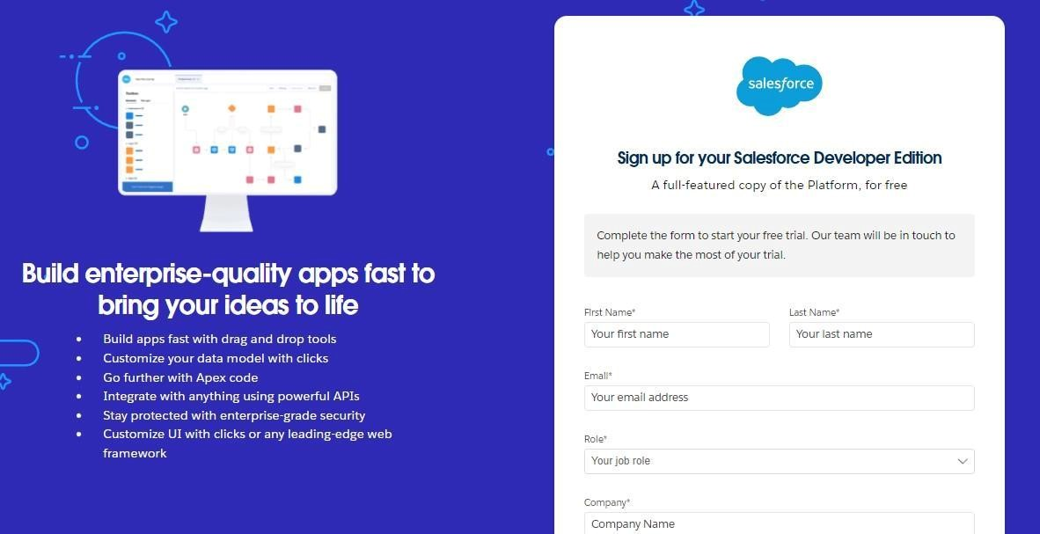

1. First name & Last name: DIJRISKTA Team
2. Email : ****@gmail.com
3. Role : Developer
4. Company : Anna University Regional Campus Coimbatore
5. County : India
6. Postal Code : 641 046
7. Username : should be a combination of your name and company

This need not be an actual email id, you can give anything in the format : username@organization.com

Click on sign me up after filling these.

**Activity 2: Account Activation**

1. Go to the inbox of the email that you used while signing up. Click on the verify account to activate your account. The email may take 5-10mins.

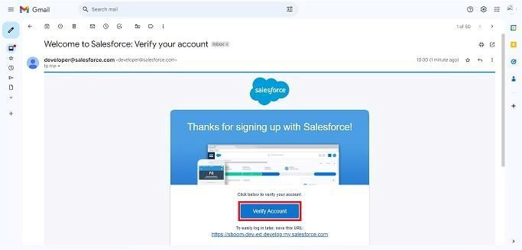

1. Click on Verify Account
2. Give a password and answer a security question and click on change password.
3. Then you will redirect to your salesforce setup page.

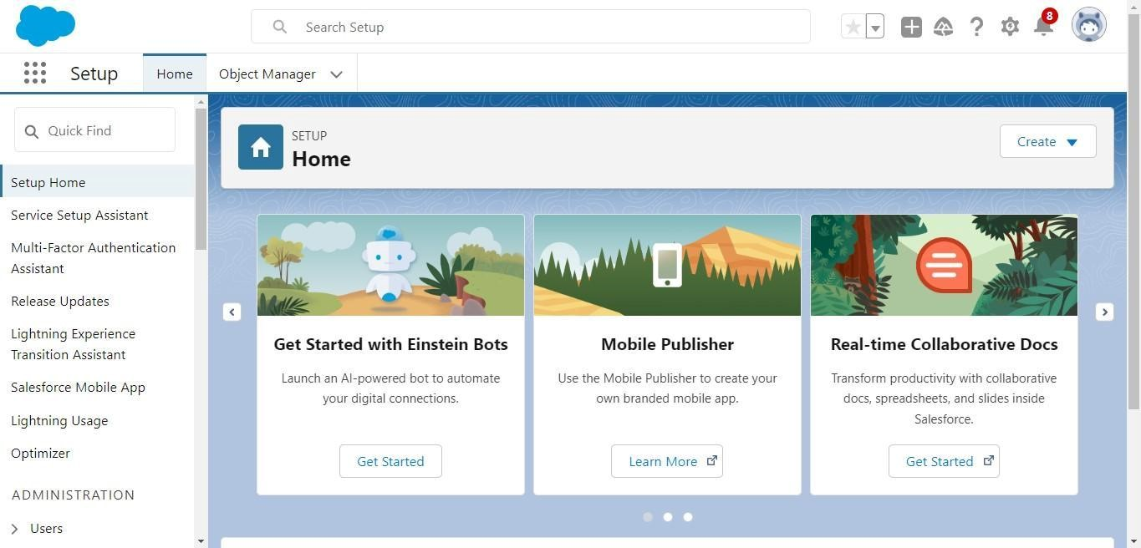

# Milestone 2- Object

**What Is an Object?**

Salesforce objects are database tables that permit you to store data that is specific to an organization. What are the types of Salesforce objects

**Salesforce objects are of two types:**

1. **Standard Objects**: Standard objects are the kind of objects that are provided by salesforce.com such as users, contracts, reports, dashboards, etc.
2. **Custom Objects:** Custom objects are those objects that are created by users. They supply information that is unique and essential to their organization. They are the heart of any application and provide a structure for sharing data.

**Use Case:**

Creating an object in Salesforce organization is essential for efficient data management and process automation. By defining custom objects, businesses can structure and store data specific to their needs, enabling streamlined workflows, personalized reporting, and enhanced user experiences. Objects serve as the foundation for organizing and leveraging critical information within Salesforce. As an Admin for TheSmartBridge, It’s your responsibility to store the data as per the organization needs.

**To Navigate to Setup page:**

Click on gear icon → click setup.

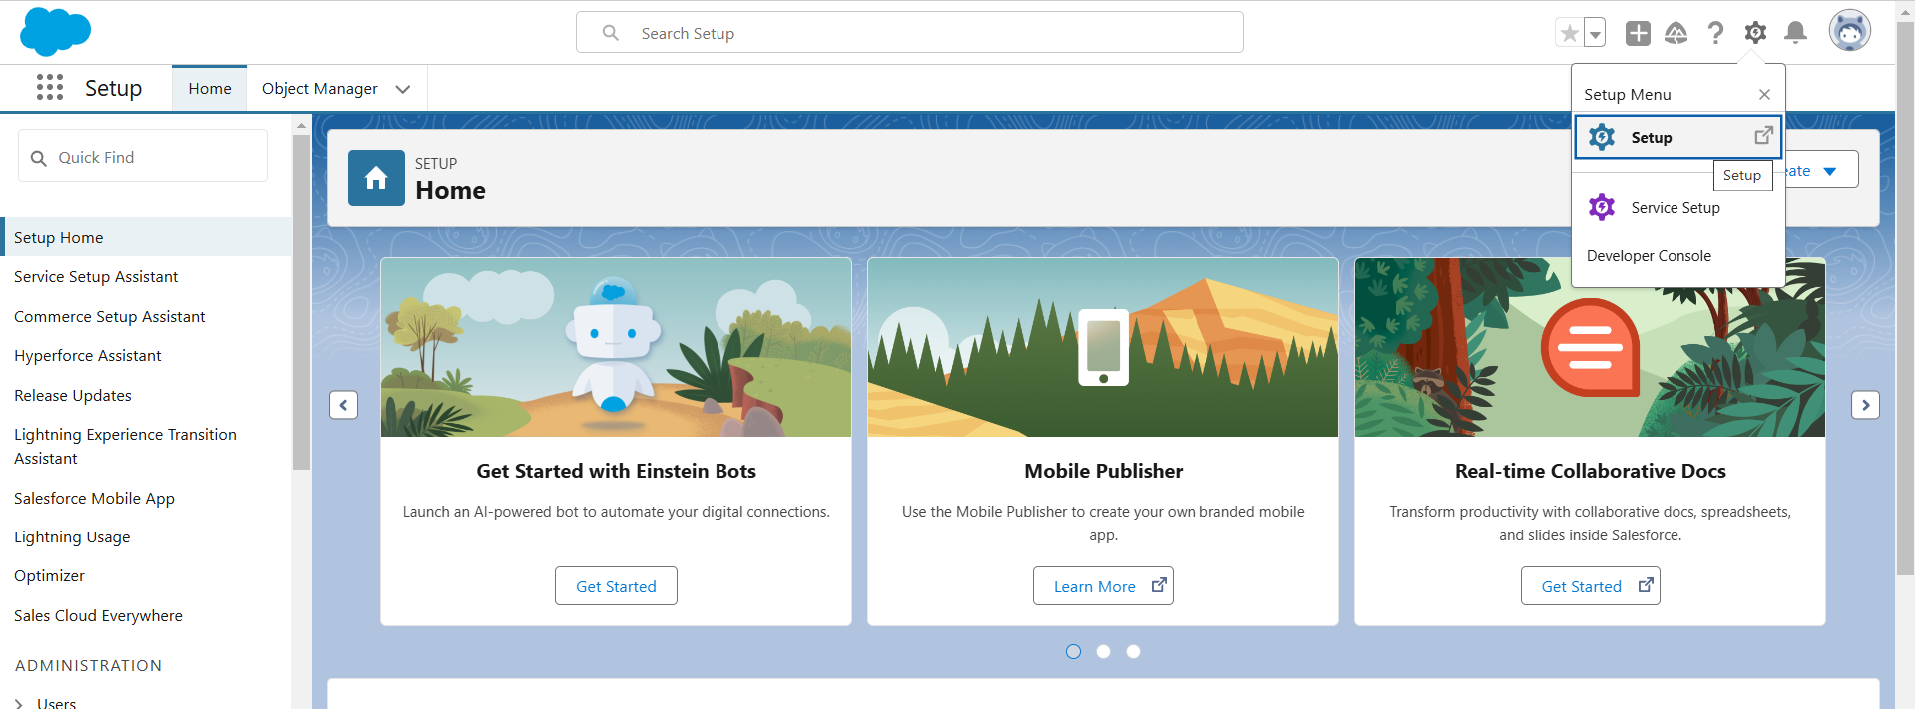

**Activity 1: Create Employee Object**

The purpose of creating an Employee custom object is to keep track of the employee’s activities and their individual and as well as team progress.

To create an object:

1. From the setup page → Click on Object Manager → Click on Create → Click on Custom Object.

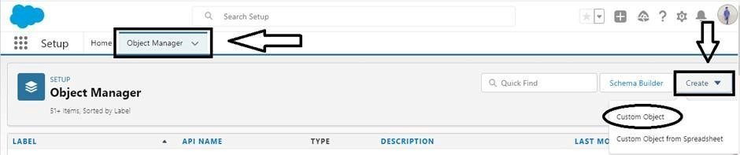

* + 1. Enter the label name→ Employee
    2. Plural label name→ Employees

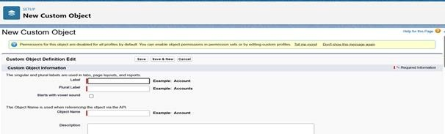

* + 1. Enter Record Name Label and Format
       - Record Name → Employee ID
       - Data Type → Auto Number
       - Display Format → EMS-{0000} ● Starting Number → 1

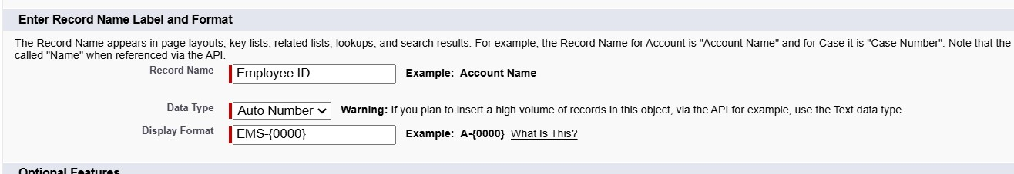

1. Click on Allow reports,
2. Allow search → **Save.**

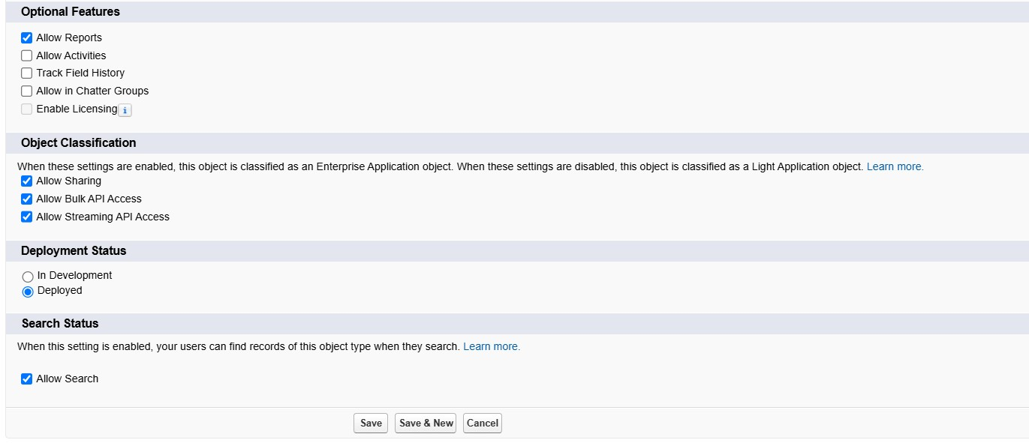

**Activity 2: Create Project Object**

The purpose of creating a project object is to have detailed information about the on-going and completed projects in the organization.

To create an object:

* 1. From the setup page → Click on Object Manager → Click on Create → Click on Custom Object.
  2. Enter the label name→ Project
  3. Plural label name→ Projects
  4. Enter Record Name Label and Format
     + - Record Name → Project ID
       - Data Type → Auto Number
       - Display Format → Proj-{0000}
       - Starting Number → 1
  5. Click on Allow reports,
  6. Allow search → **Save**

**Activity 3: Create 3 more objects with label names as ProjectTask, and , Asset Service.**

**Note:** use “Text” as a data type and label Record Name as “Project Task Name”.



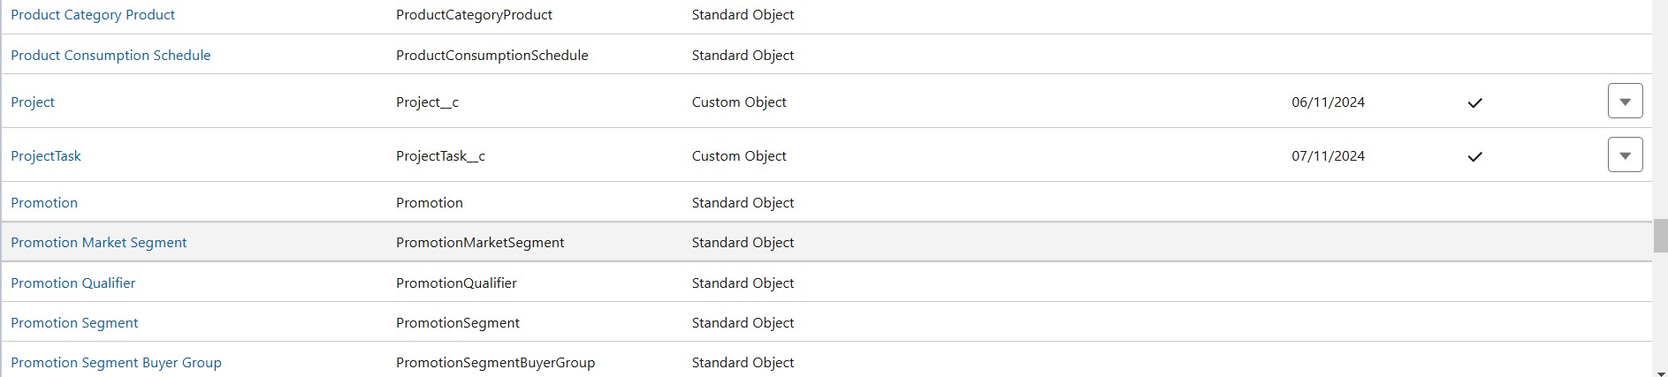

# Milestone 3 - Tabs

**What is Tab:** A tab is like a user interface that is used to build records for objects and to view the records in the objects.

**Types of Tabs:**

## 1. Custom Tabs

Custom object tabs are the user interface for custom applications that you build in salesforce.com. They look and behave like standard salesforce.com tabs such as accounts, contacts, and opportunities.

## 2. Web Tabs

Web Tabs are custom tabs that display web content or applications embedded in the salesforce.com window. Web tabs make it easier for your users to quickly access content and applications they frequently use without leaving the salesforce.com application.

## 3. Visualforce Tabs

Visualforce Tabs are custom tabs that display a Visualforce page. Visualforce tabs look and behave like standard salesforce.com tabs such as accounts, contacts, and opportunities.

## 4. Lightning Component Tabs

Lightning Component tabs allow you to add Lightning components to the navigation menu in Lightning Experience and the mobile app.

## 5. Lightning Page Tabs

Lightning Page Tabs let you add Lightning Pages to the mobile app navigation menu.

Lightning Page tabs don't work like other custom tabs. Once created, they don't show up on the All Tabs page when you click the Plus icon that appears to the right of your current tabs. Lightning Page tabs also don't show up in the Available Tabs list when you customize the tabs for your apps.

**Use Case:**

Creating Objects and storing TheSmartBridge organization’s data is the very first step in the requirements they want. Now to access the stored data by an employee from the organization Admin needs to create Tabs. By designing a dedicated Tab, businesses can improve user experience, simplify navigation, and provide quick access to critical information, enhancing productivity and ensuring efficient utilization of Salesforce's capabilities.

**Activity 1: Creating a Custom Tab**

**To create a Tab:(Employee)**

1. Go to setup page → type Tabs in Quick Find bar → click on tabs → New (under custom object tab)

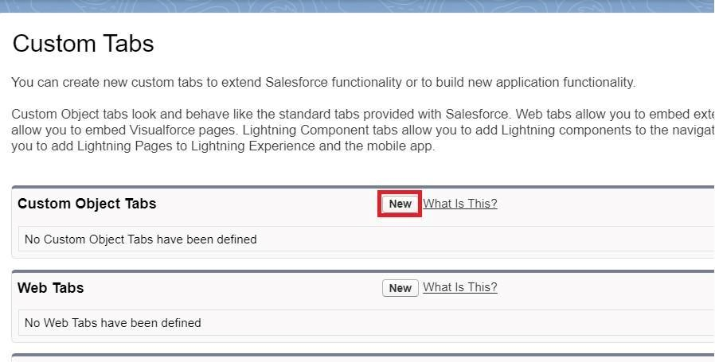

1. Select Object(Employee) → Select any tab style → Next (Add to profiles page) keep it as default → Next (Add to Custom App) keep it as default → Save.

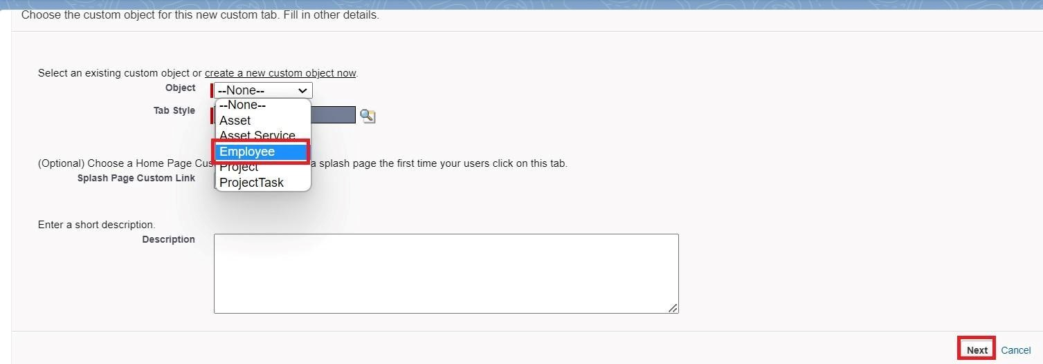

**Activity 2:**

## To create a Tab:(Project)

1. Go to setup page → type Tabs in Quick Find bar → click on tabs → New (under custom object tab)
2. Select Object(Project) → Select the tab style → Next (Add to profiles page) keep it as default → Next (Add to Custom App) keep it as default → Save.

**Activity 3:**

Now create tabs for Project Task, Asset, Asset Services objects.

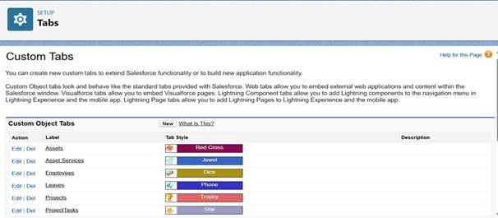

**Milestone 4 - The Lightning App:**

An app is a collection of items that work together to serve a particular function. In Lightning Experience, Lightning apps gives users access to sets of objects, tabs, and other items all in one convenient bundle in the navigation bar.

Lightning apps let you brand your apps with a custom color and logo. You can even include a utility bar and Lightning page tabs in your Lightning app. Members of your org can work more efficiently by easily switching between apps.

**Use Case:**

Well done you have reached close to your organizational requirement by creating the objects to store the organization’s data. Making a database for an organization is just not enough to reach out the requirements, the task is how the users at the organization can access the objects you have created for them. As an Admin for the TheSmartBridge organization it's your duty to make sure every user of the organization is able to access the data modeling structure.

**Activity 1: Create a Lightning App To create a lightning app page:**

1. Go to setup page → search “app manager” in quick find → select “app manager” → click on New lightning App.

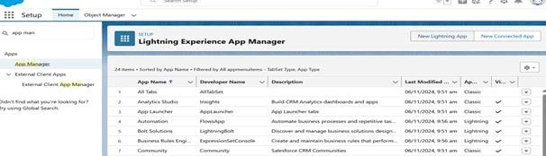

1. Fill the app name in app details and branding as follow

App Name : Workforce Administrator Solution

Developer Name : this will auto populated

Description : Give a meaningful description

Image : optional (if you want to give any image you can otherwise not mandatory) Primary color hex value : keep this default

1. Then click Next → (App option page) keep it as default → Next → (Utility Items) keep it as default → Next.

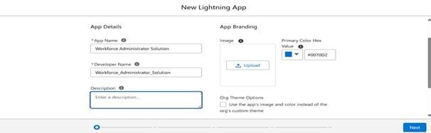

1. To Add Navigation Items:

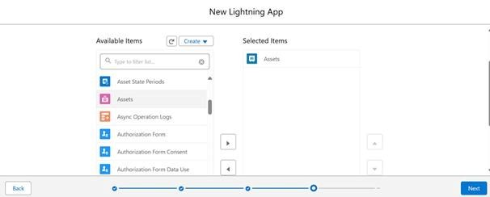

Search the items in the search bar(Employees, Projects, ProjectTask, Assets, Asset Services, Reports, Dashboard) from the search bar and move it using the arrow button → Next.**Note**: select asset the custom object which we have created in the previous activity.

1. To Add User Profiles:

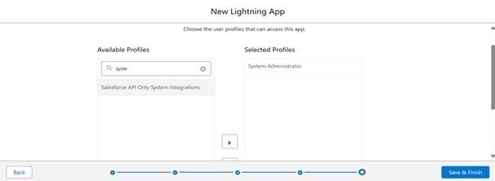

Search profiles (System administrator) in the search bar → click on the arrow button → save & finish.

# Milestone 5 - Fields

When we talk about Salesforce, Fields represent the data stored in the columns of a relational database. It can hold any valuable information that you require for a specific object. Hence, the overall searching, deletion, and editing of the records become simpler and quicker.

Types of Fields

1. Standard Fields
2. Custom Fields

**Standard Fields:**

As the name suggests, the Standard Fields are the predefined fields in Salesforce that perform a standard task. The main point is that you can’t simply delete a Standard Field until it is a non-required standard field. Otherwise, users have the option to delete them at any point from the application freely. Moreover, we have some fields that you will find common in every Salesforce application. They are,

* Created By
* Owner
* Last Modified
* Field Made During object Creation

**Custom Fields:**

On the other side of the coin, Custom Fields are highly flexible, and users can change them according to requirements. Moreover, each organizer or company can use them if necessary. It means you need not always include them in the records, unlike Standard fields. Hence, the final decision depends on the user, and he can add/remove Custom Fields of any given form.

**Use Case:**

Now it’s time for you to think out of the box for your organization. You have successfully created the database objects for the organization but now all eyes turn on you as you have to define what sort of information the objects store which you have created. As a life saver of your organization you come up with the idea of creating fields to store different types of data.

**Activity 1 : Creating Text Field in Employee Object**

To create fields in an object:

1. Go to setup → click on Object Manager → type object name(Employee) in quick find bar→ click on the object.

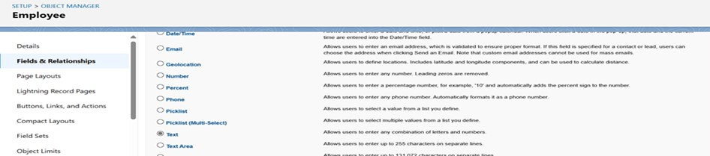

1. Now click on “Fields & Relationships” → New

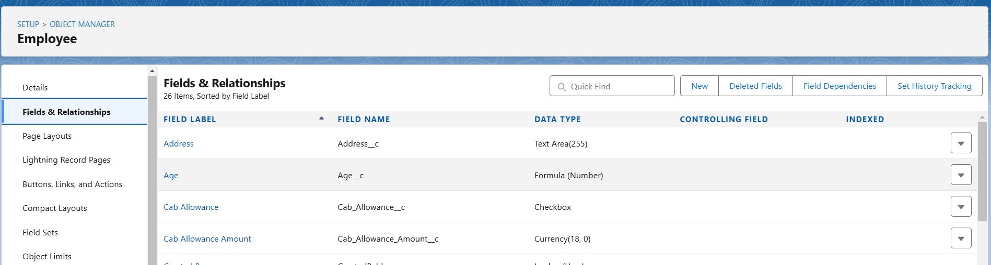

1. Select Data type as “Text”.

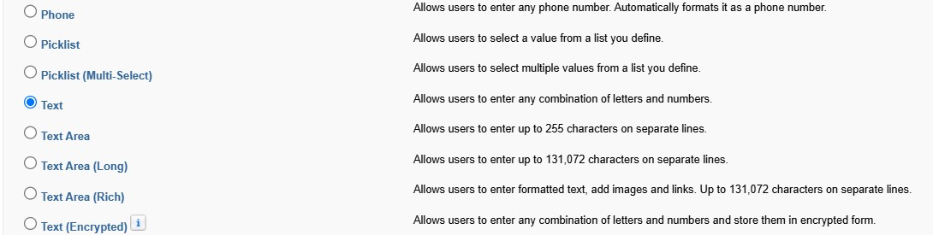

1. Click on Next

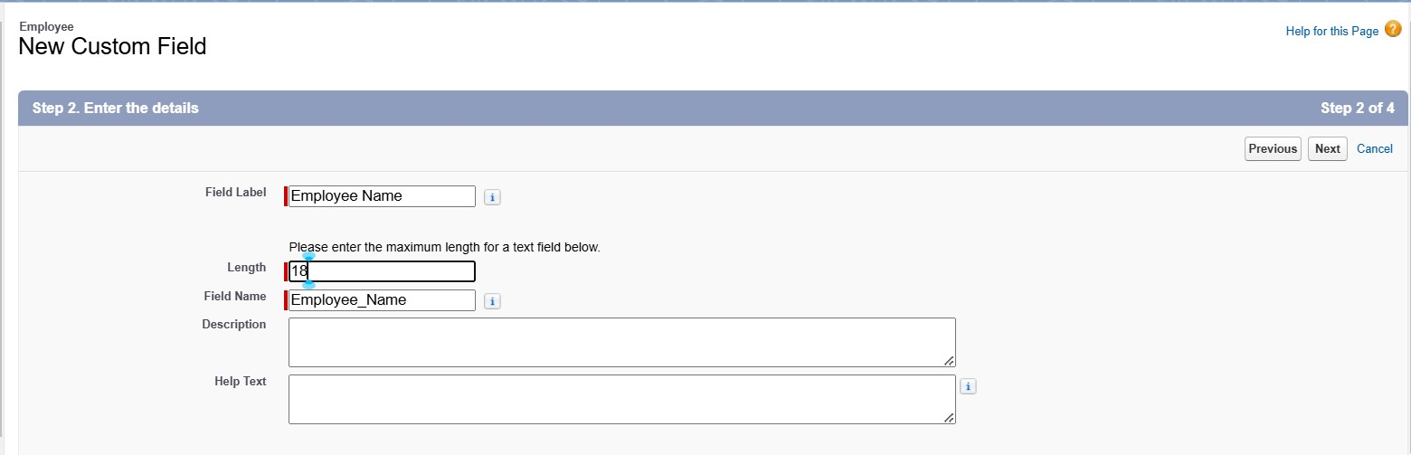

1. Fill the above as following:

○ Field Label : Employee Name

○ Length : 18

○ Field Name : gets auto generated

○ Click on Next → Next → Save and new.

**Activity 2 : Creating Date of Birth Field in Employee Object**

1. Repeat step 1 and 2 mentioned in activity 1
2. Select Data type as “Date” and click Next.

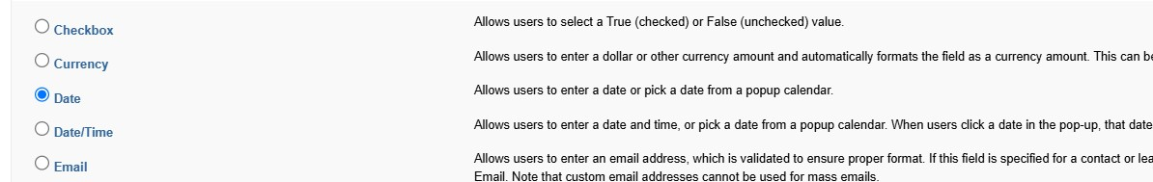

1. Click on Next.
2. Fill the above as following:
   1. Field Label: Date of Birth.
   2. Field Name : gets auto generated.
   3. Click on Next → Next → Save and new.

**Activity 3 : Creating Formula Field in Employee Object**

1. Repeat step 1 and 2 mentioned in activity 1
2. Select Data type as “Formula” and click Next.

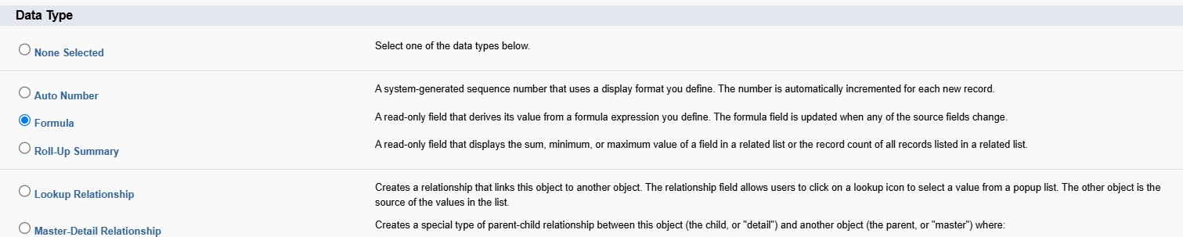

1. Give Field Label and Field Name as “Age” and select formula return type as “Number” and click next.

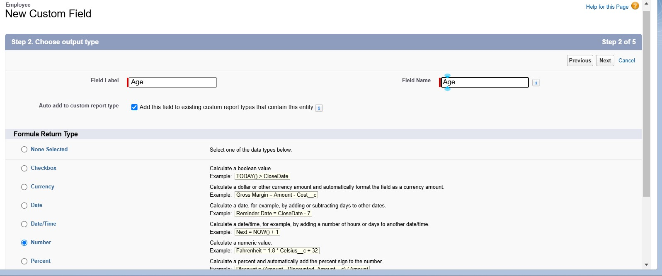

1. Under Advanced Formula write down the formula and click “Check Syntax” and Next→ Next→ Save & New.

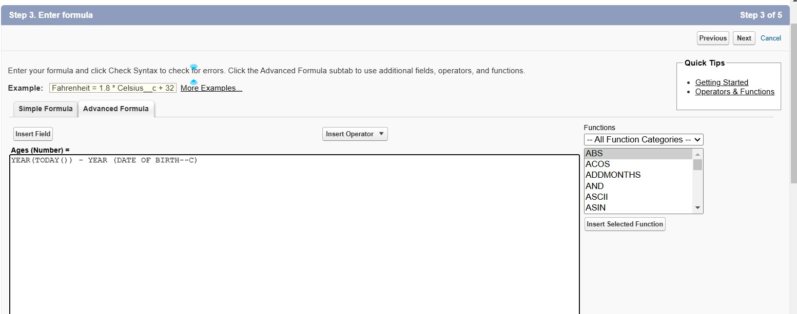

**Activity 4 : Creating Picklist Field in Employee Object**

1. Repeat step 1 and 2 mentioned in activity 1
2. Select Data type as “Picklist” and click Next.

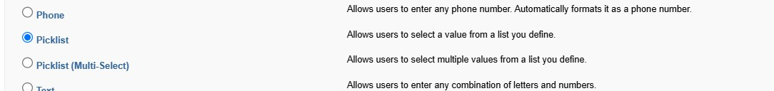

1. Enter Field Label as “Gender”, under values select “Enter values, with each value separated by a new line" and enter values as shown below.

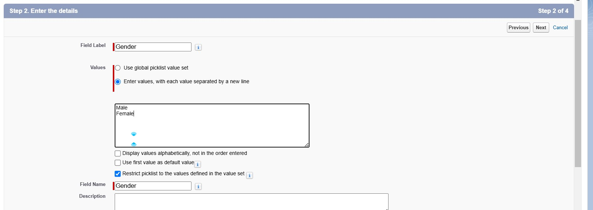

1. Click Next→ Next → Next → Save & New.

**Activity 5 : Creating Self-Relationship Field in Employee Object**

1. Repeat step 1 and 2 mentioned in activity 1
2. Select Data type as “Lookup Relationship” and click Next.

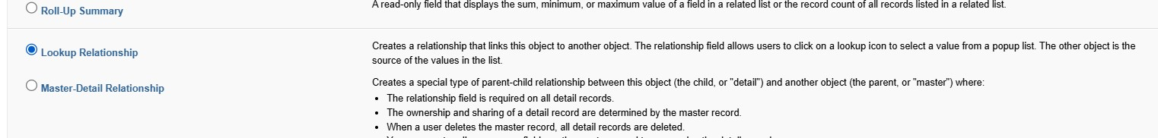

1. Select Employee from the drop down related to the field and click Next.

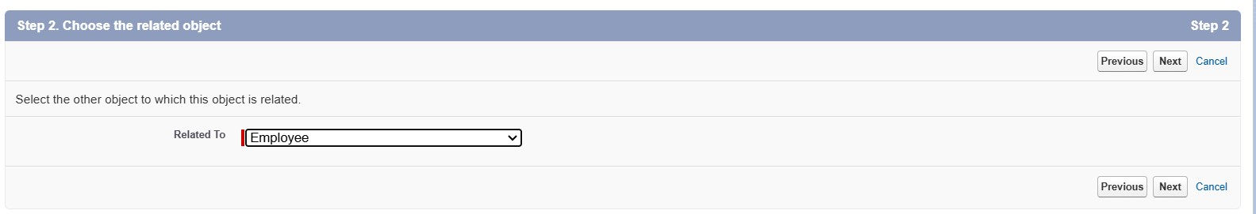

1. Give Field Label as “Reports to” and click Next.
2. Next → Next → Save & New.

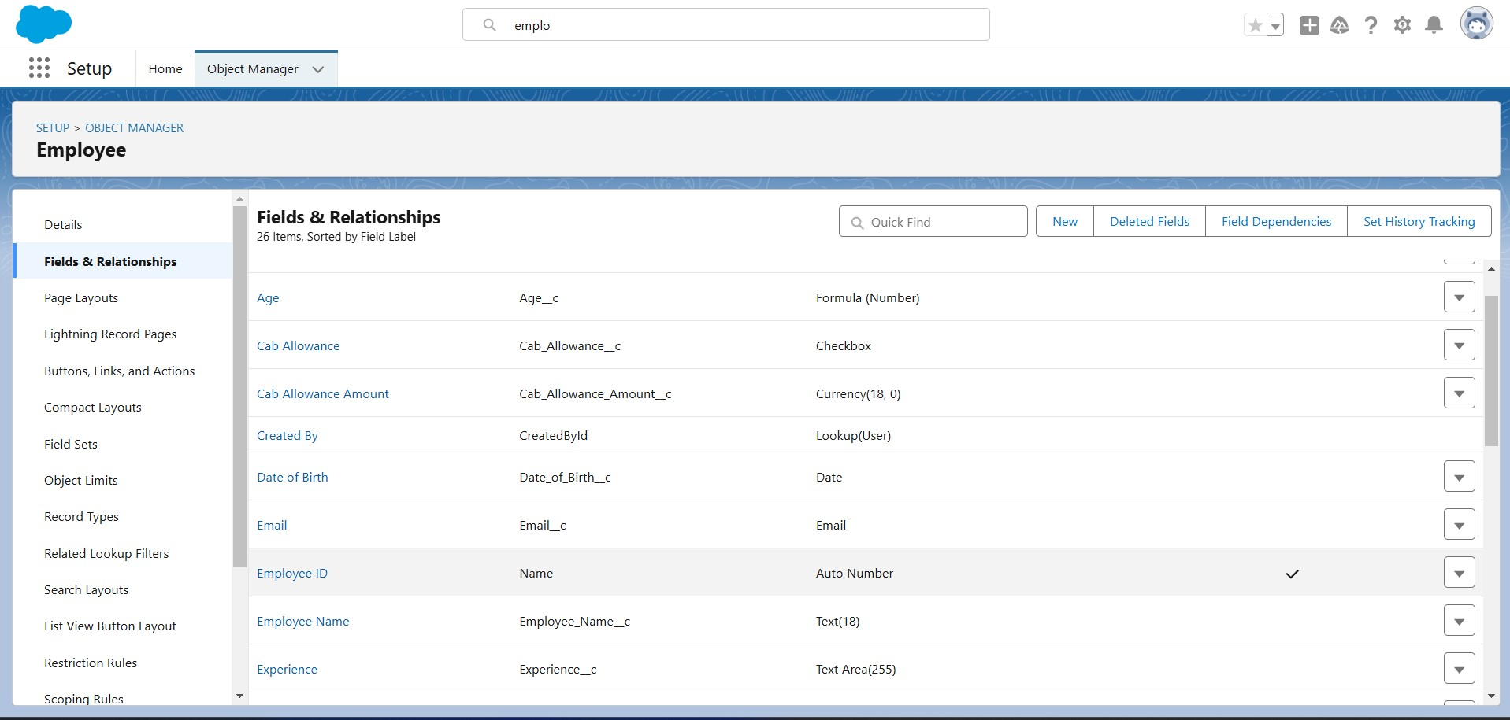

**Activity 6 : Master-Detail Relationship**

**Creating Master-Detail Relationship between Employee & ProjectTask Object** To Create a Master-Detail relationship

1. Go to the setup page → click on object manager → type object name(ProjectTask) in the quick find bar→ click on the object.
2. Click on fields & relationship → click on New.
3. Select “Master-Detail relationship” as data type and click Next.
4. For field label related to: select “Employee” object and click Next.
5. Give Field Label as “Employee Name” and click Next.
6. Next → Next → Save & New.

**Activity 7 : Creating Remaining Fields in Employee Object**

Now create the remaining fields using the data types mentioned in the table.

|  |  |  |
| --- | --- | --- |
| Sl No | Object Name | Field |
| 1 | Employee | |  |  |  | | --- | --- | --- | |  | **Field Name** | **Data type** | | ● | Qualification | Text | | ● | Address | Text Area | | ● | Experience | Text Area | | ● | Phone no | Phone | | ● | Email | Email | | ● | Joining date | Date | | ● | Mode of Work | Picklist: Values   |  | | --- | | On Site  Remote | | | ● | Cab Allowance | Check box | | ● | Food Allowances | Check box | | ● | Wifi Allowances | Check box | | ● | Cab Allowance Amount | Currency | | ● | Food Allowance Amount | Currency | | ● | Wifi Allowance Amount | Currency | | ● | Login Time | Time | | ● | Logout Time | Time | | ● | LinkedIn Profile | url | |

|  |  |  |  |  |  |  |  |  |  |  |  |
| --- | --- | --- | --- | --- | --- | --- | --- | --- | --- | --- | --- |
| 2 | Project | |  |  |  | | --- | --- | --- | |  | **Field Name** | **Data type** | | ●  ●  ●  ●  ● | Project Name  Project Lead  Start Date  End Date  Project Status | Text  Text  Date  Date  Picklist: Values   |  | | --- | | Completed  On Going  Not Yet Started | | | | |
| 3 | Project Task | |  |  |  | | --- | --- | --- | |  | **Field Name** | **Data type** | | ●  ●  ●  ●  ● | Project Task  Finishes in  Working Hours  Employee Name  Asset Id | MDR with project object **Formula** :  (Project_Task__r.Start_D ate__c -  Project_Task__r.End_Dat e__c )  **Formula return type**:  Number  Numbers  Master Detail relationship with  Employee object  Lookup relationship with Asset object |   **Note:** here in Finishes in field, Start Date and End Date belong to Employee Object. | | |
|  |  | |  |  |  | | --- | --- | --- | |  | **Field Name** | **Data type** | | ● | Asset Id | Lookup relationship with  Asset object | | | |
| 4 | Asset Service |  | | |
| * Type * Technician * Subject * Description | |  | | --- | | Technical Issue  Non Technical Issue |   Picklist: Values  Text  Text Area  Text Long |  |
|  | |
| 5 | Asset | |  |  | | --- | --- | | **Field Name** | **Data type** | | * Asset Type * Model Name * Employee Name * Date of Issue | Picklist: Values   |  | | --- | | Laptop  Charger  Mouse  Monito  CPU |   Text  Lookup relationship with  Employee Object  Formula(Joining date)  Formula Return type: date | | | |

# Milestone 6 - Setting OWD

Organization-Wide Defaults, or OWDs, are the pattern security rules that you can follow for your Salesforce instance. Organization Wide Defaults are utilized to confine who can access what information in your CRM. You can award access through different methods that we will discuss later (sharing principles, Role Hierarchy, Sales Teams, and Account groups, manual sharing, and so forth).

Primarily, there are four levels of access that can be set in Salesforce OWD and they are-

* Public Read/Write/Transfer
* Public Read/Write
* Public Read/Only
* Private

**Use Case:**

Data is the most precious thing of any organization and keeping it safe is the first most priority of any Admin in the organization. As an Admin, to ensure data privacy and compliance with regulations, you need to restrict access to sensitive customer information using OWD.

**Activity 1:**

Create OWD Setting

1. Go to Set Up→ in the Quick Find box type Sharing Settings → click on it.
2. Click Edit in the Organization-Wide Defaults area.

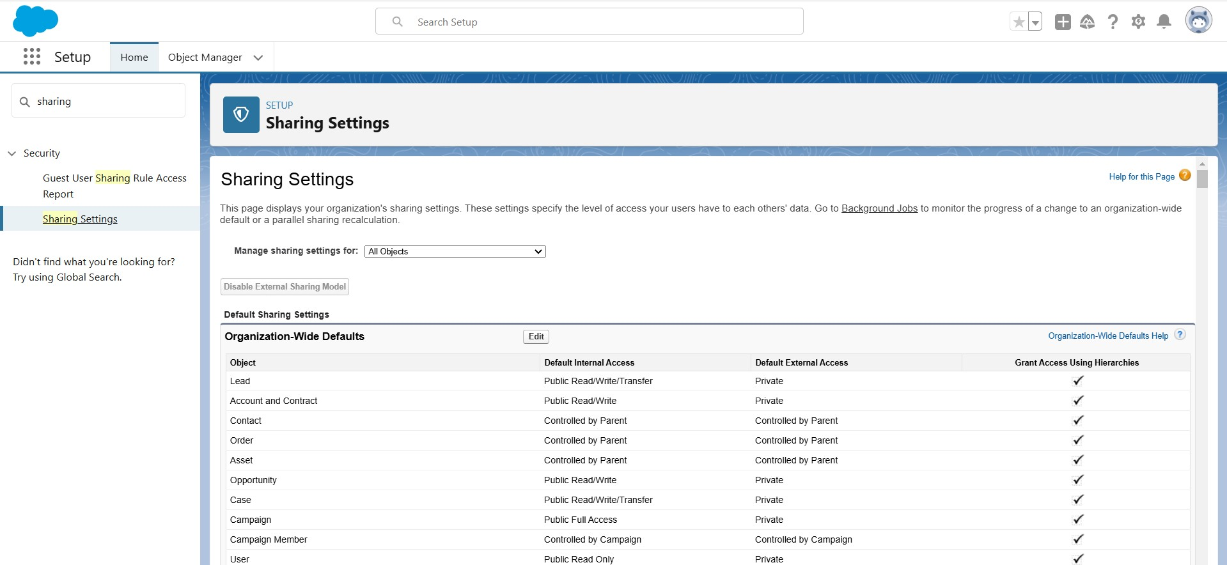

1. Search for the Employee object.
2. Under default internal access and default external access change the options to “Private” and under grant access using hierarchies select the check box.
3. Click on save.

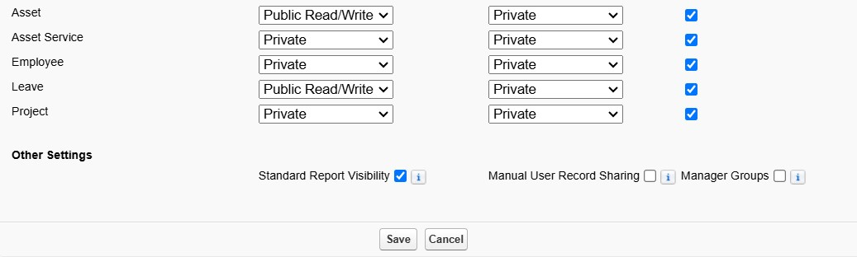

1. This Setting is for all the Users Which have been Created.

**Activity 2:**

Set OWD as Private for Project and Asset Service objects.

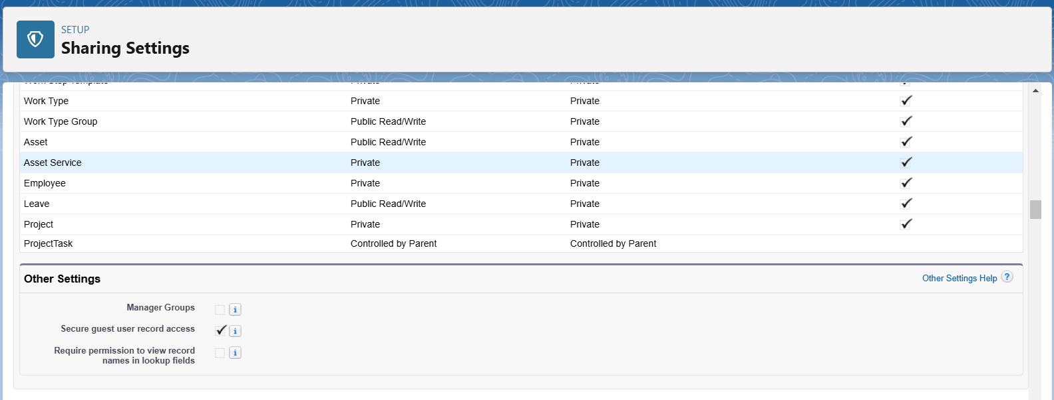

# Milestone 7 - User Adoption

**Use Case:**

As a new Administrator, you perform user management tasks like creating and editing users, resetting passwords, granting permissions, configuring data access, and much more. In this unit, you will learn about users and how you add users to your Salesforce org.

**Activity 1:**

Create a Record (Employee)

1. Click on App Launcher on the left side of the screen.
2. Search Employee Management System & click on it.

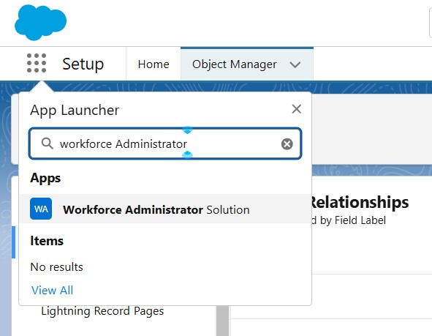

1. Click on the Employee tab.
2. Click New.

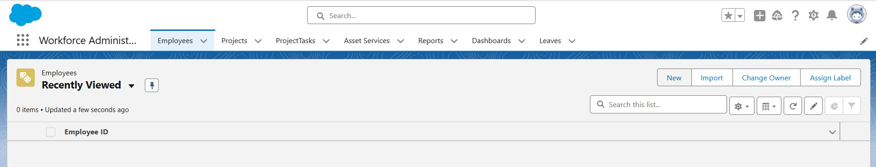

1. Fill the Details and click on Save.

**Activity 2:**

View a Record(Employee)

1. Click on App Launcher on the left side of the screen.
2. Search Employee Management System & click on it.
3. Click on the Employee Tab.
4. Click on any record name. you can see the details of the Employee

**Activity 3:**

Delete a Record(Employee)

1. Click on App Launcher on the left side of the screen.
2. Search Employee Management System & click on it.
3. Click on the Employee Tab.
4. Click on Arrow at right hand side on that Particular record.
5. Click delete.

**Activity 4:**

Create at least 10 records for each of the objects: Asset, Project, Project Task, Asset Service.

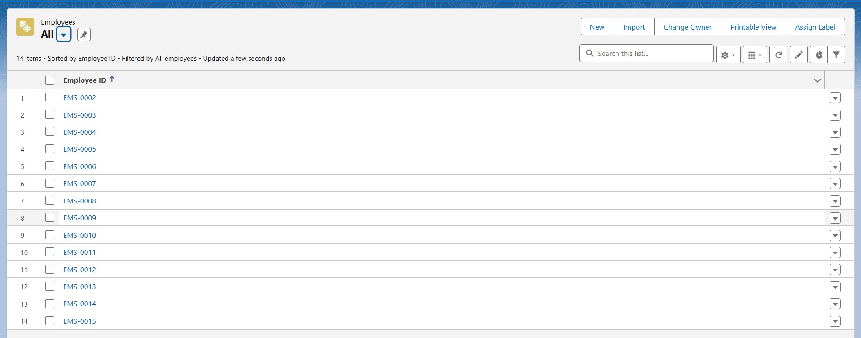

# Milestone 8 - Import Data

NOTE- Before creating the application download this file from the URL given below and save the file in CSV.

<https://tinyurl.com/SF-Employee-Data>

Data Import lets you upload data from external sources and combine it with data you collect via Analytics. You can then use Analytics to organize and analyze all of your data in ways that better reflect your business.

The Data Import Wizard is a Tool makes it easy to import data for many standard Salesforce objects, including accounts, contacts, leads, solutions, campaign members, and person accounts. You can also import data for custom objects.

In order to complete this milestone, you need to create CSV files and give them data given in the picture below. After that from these CSV files we will import data for the Employee object.

**Use Case:**

Congrats you have successfully made an app with all the default settings for the organization. Now here comes the real admin work, to import the old data of TheSmartBridge organization which was in CSV format into the salesforce org without failing any of the record. Note in real time you might also facing some additional task such as data cleaning, elimination of duplicate values or records, etc., **Activity-1:**

1. From Setup, click the Home tab.
2. In the Quick Find box, enter Data Import and select Data Import Wizard.

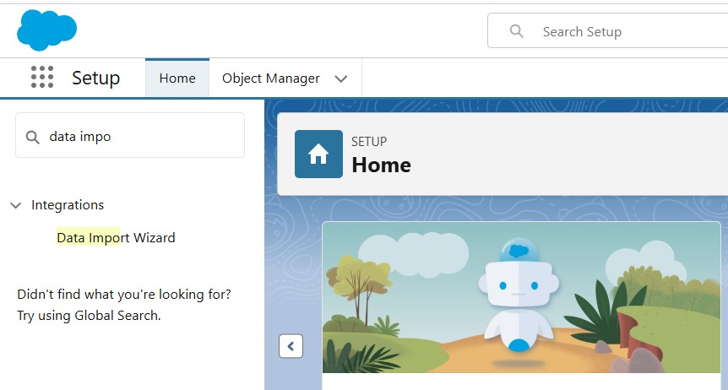

1. Click Launch Wizard!

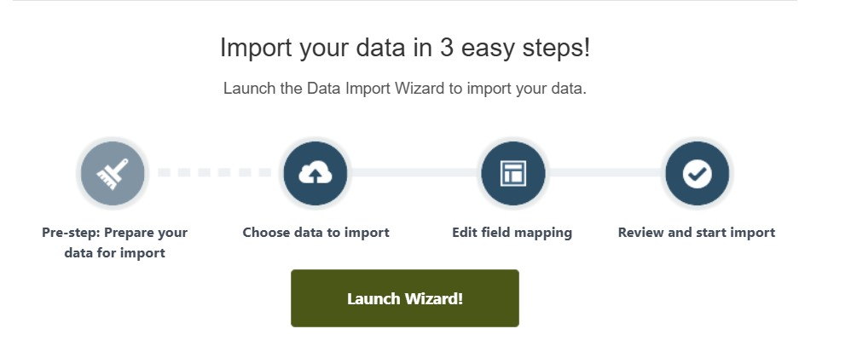

1. Click the Custom Objects tab and select the Employee object.

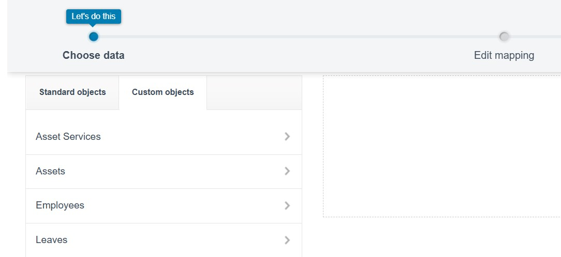

1. Select Add new records.

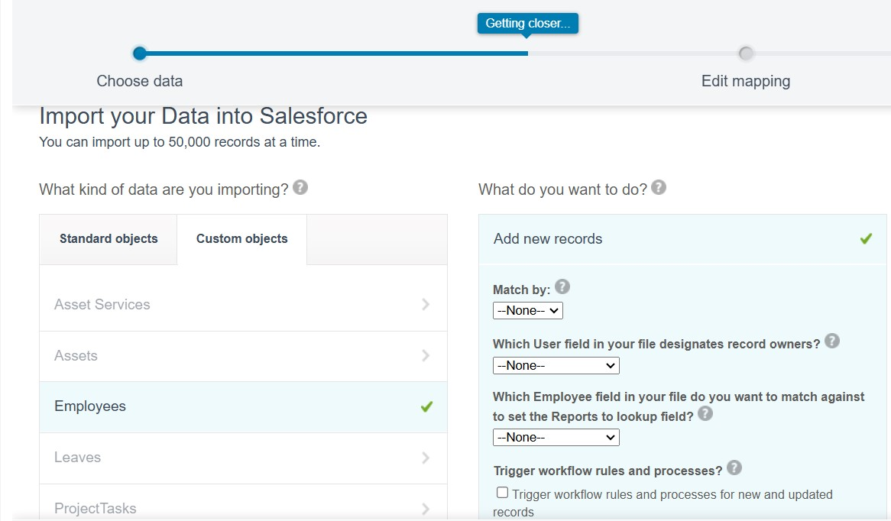

1. Click CSV and choose file Employee_CSV which we made earlier. Click Next.

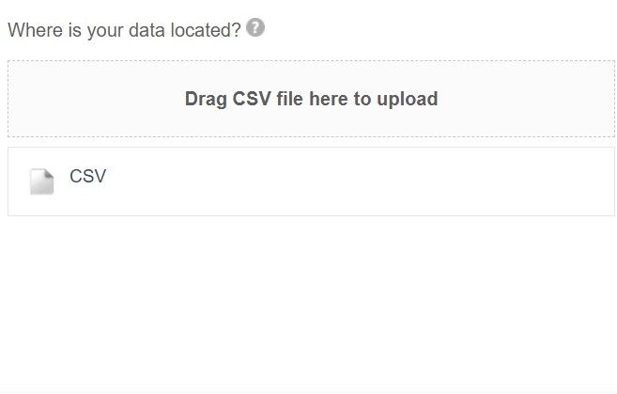

1. Since the field names in the CSV file (CSV Header) are the same as the field names in your object (Mapped Salesforce Object), the fields are automatically mapped. Click Next.

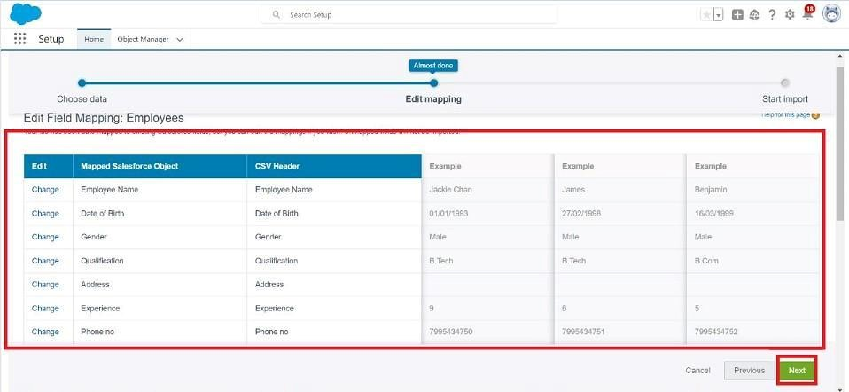

**Note**: no need to map “Reports to” field. The Data Import Wizard is designed to handle basic data import tasks and does not support mapping relationships between records.

1. The next screen gives you a summary of your data import. Click Start Import.

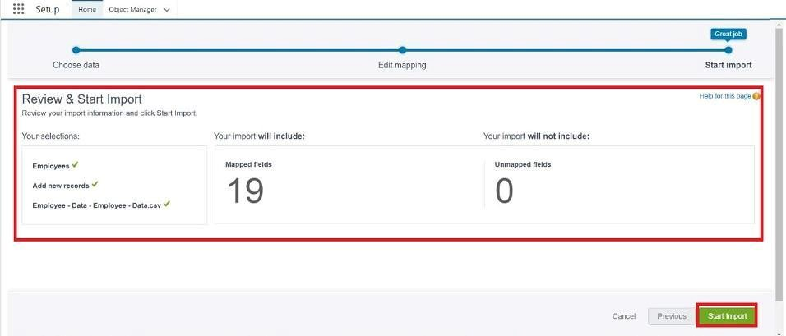

1. Click OK on the popup.

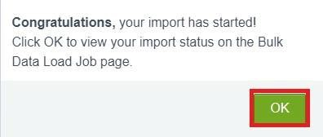

1. Scroll down the page and verify that your data has been imported under batches.

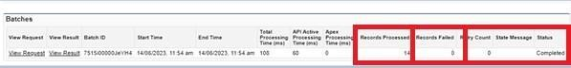

1. Make sure you have 0 records under the records failed column.

# Milestone 9 - Profiles

A profile is a group/collection of settings and permissions that define what a user can do in salesforce. Profile controls “Object permissions, Field permissions, User permissions, Tab settings, App settings, Apex class access, Visualforce page access, Page layouts, Record Types, Login hours & Login IP ranges. You can define profiles by the user's job function. For example System Administrator, Developer, Sales Representative.

**Types of profiles in salesforce**

1. **Standard profiles:**

By default salesforce provides below standard profiles.

* + Contract Manager
  + Read Only
  + Marketing User
  + Solutions Manager
  + Standard User
  + System Administrator.

We cannot deleted standard ones

Each of these standard ones includes a default set of permissions for all of the standard objects available on the platform.

1. **Custom Profiles:**

Custom ones defined by us.

They can be deleted if there are no users assigned with that particular one.

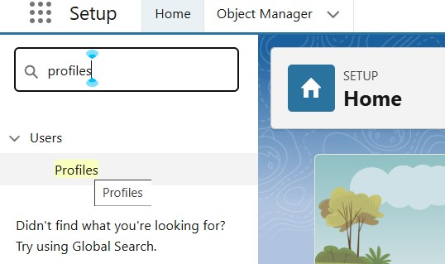

**Use Case:**

Great work Admin, you have done so good till now. TheSmartBridge CEO wants you to differentiate the users based on their functionalities, position and based on this those users need to have the minimum access to the database object in the organization. Now it's time to use your Admin skills to focus on the users, their functionality and position in the organization in order to achieve the CEO requirements.

**Activity 1: HR Profile**

**To create a new profile:**

1. Go to setup → type profiles in quick find box → click on profiles → clone the desired profile (Standard user) → enter profile name (HR) → Save.

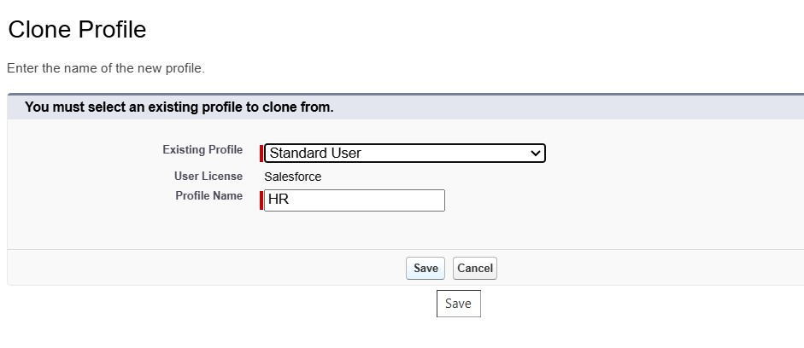

1. While still on the profile page, then click Edit.
2. Scroll down to Custom Object Permissions and Give access permissions for Assets and Asset Services objects.

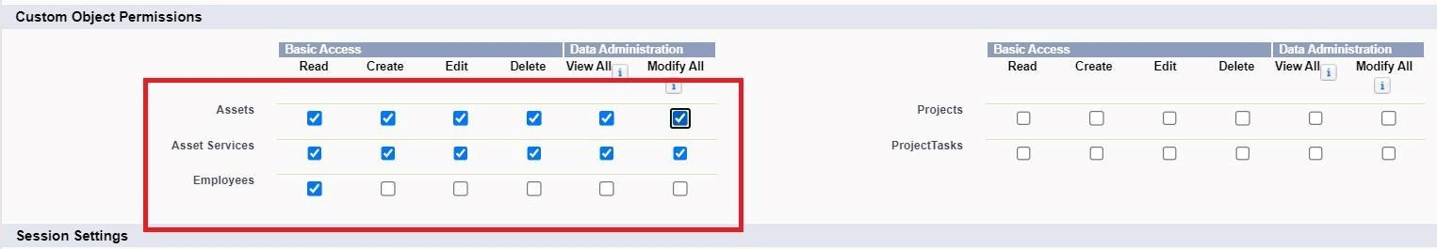

1. Scroll down and Click on Save.

**Activity 2: Manager Profile**

1. Go to setup → type profiles in quick find box → click on profiles → clone the desired profile (Salesforce Platform User) → enter profile name (Manager) → Save.
2. While still on the profile page, then click Edit.
3. Scroll down to Custom Object Permissions and Give access permissions for Employee, Project and Project Task objects.

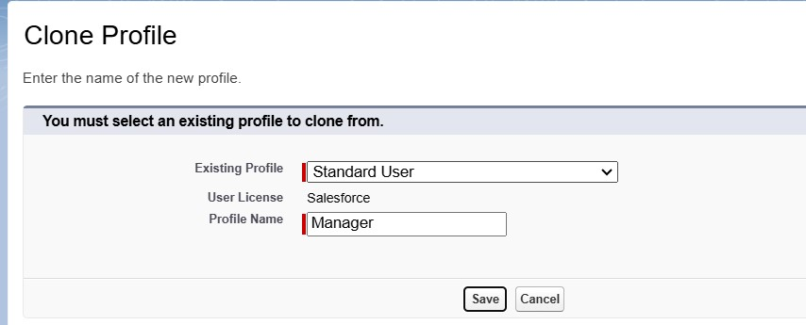

1. Scroll down and Click on Save.

**Activity 3: Create Employee Profile**

Create Employee Profiles for “On Site Employee”,”Remote Employee” as in Activity 2, but in step 3 only allow permission access for Project and Project Task objects only.

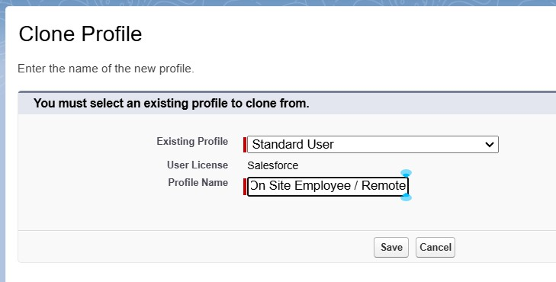

# Milestone 10 - Role

A role in Salesforce defines a user's visibility access at the record level. Roles may be used to specify the types of access that people in your Salesforce organization can have to data.

Simply put, it describes what a user could see within the Salesforce organization.

**Use Case:**

You have successfully fulfilled the 1st requirement i.e., differentiating the users based on the functionality. Now comes the 2nd task of differentiating the users based on their position, using your excellent admin skills and expanding the custom roles for the organization and assigning it to the users.

**Activity 1:**

Creating HR Role:

1. Go to quick find → Search for Roles → click on set up roles.

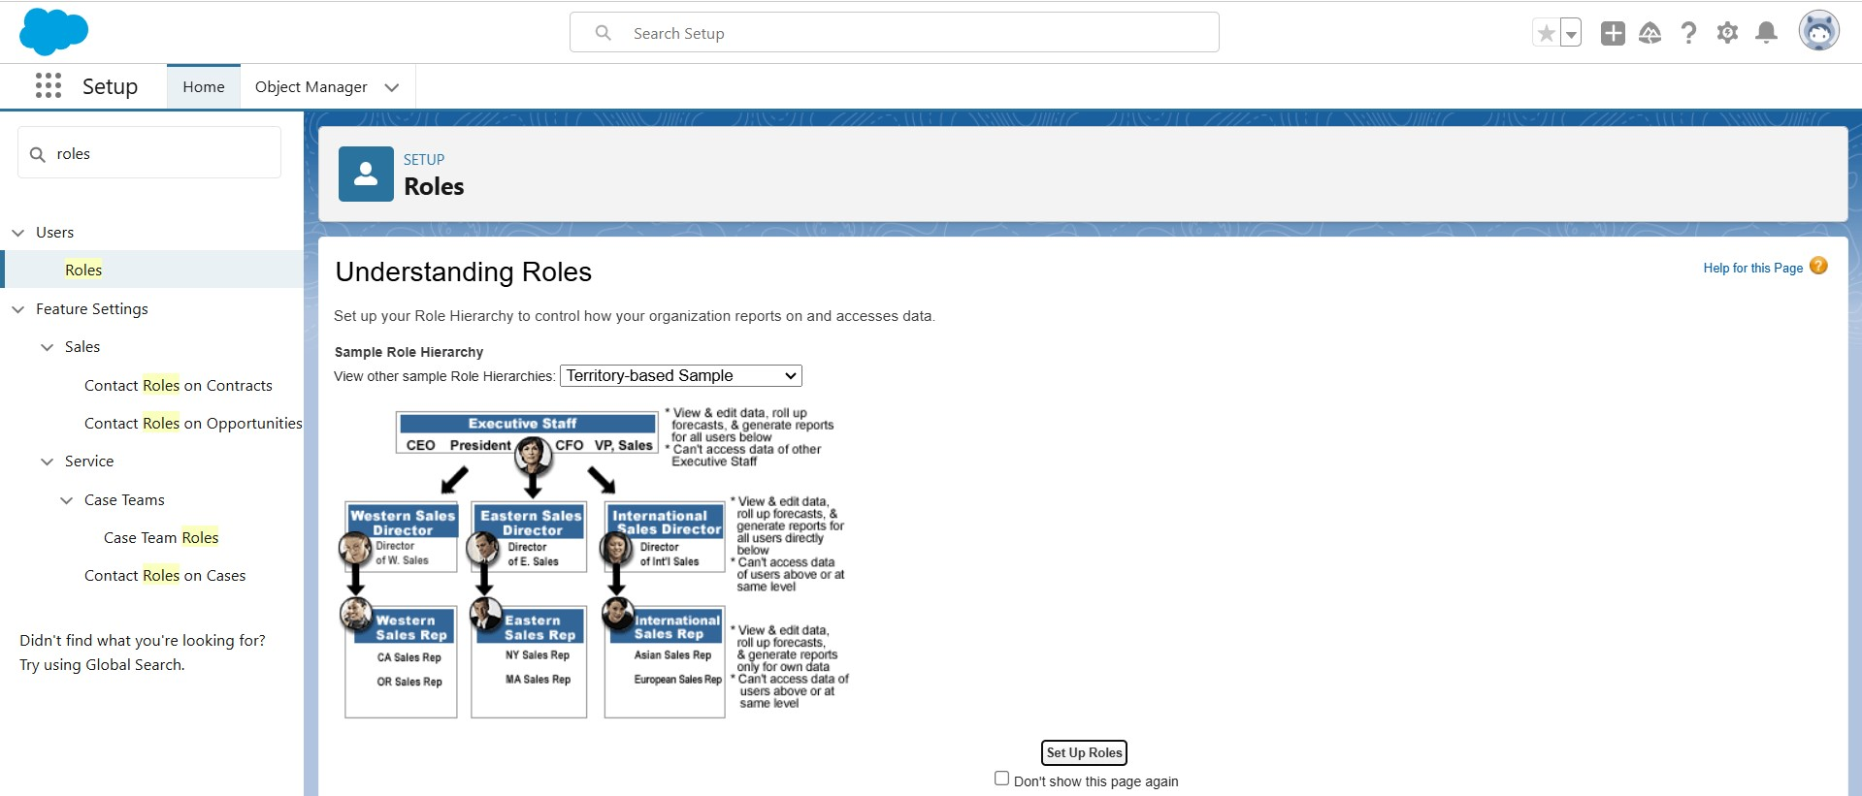

1. Click on Expand All and click on add role under whom this role works.

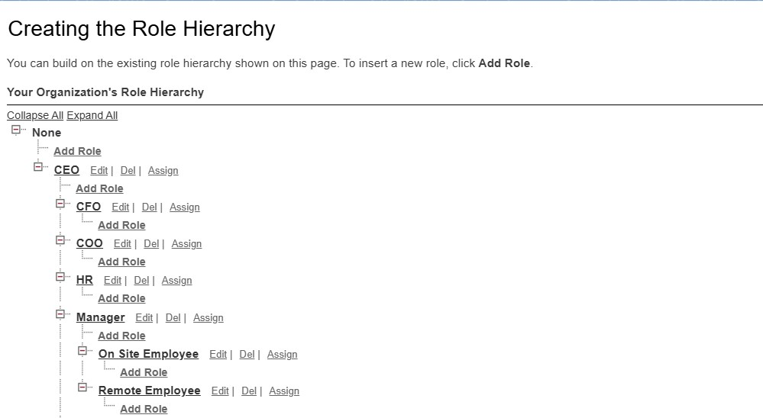

1. Give Label as “HR” and Role name gets auto populated. Check to whom this role (HR) reports. Then click on Save.

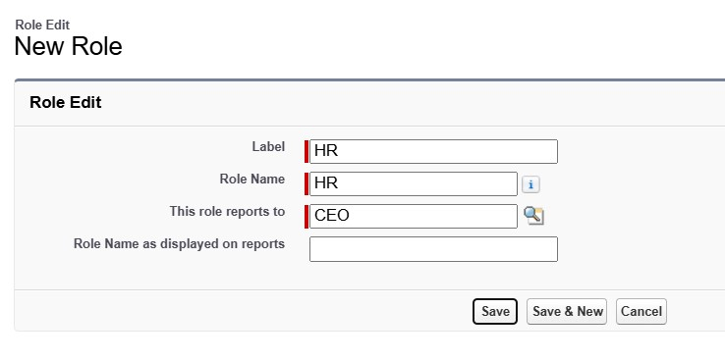

1. Refer the below diagram to understand which role reports to which role.

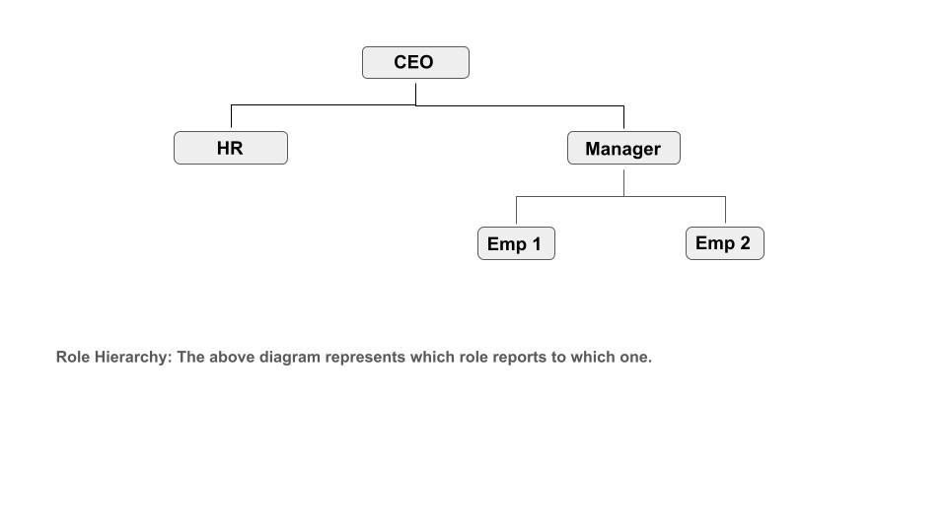

**Activity 2:**

Create three more roles for Manager, On Site Employee, Remote Employee.

**Note:** On Site Employee and Remote Employee reports to Manager.

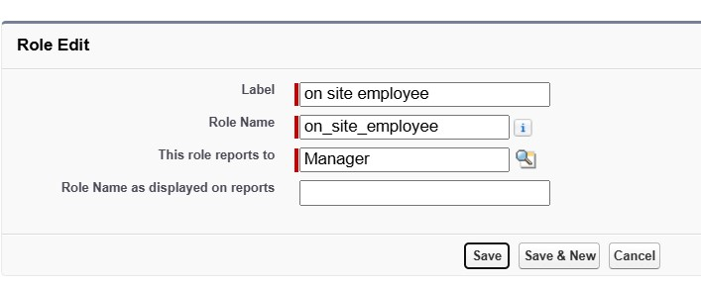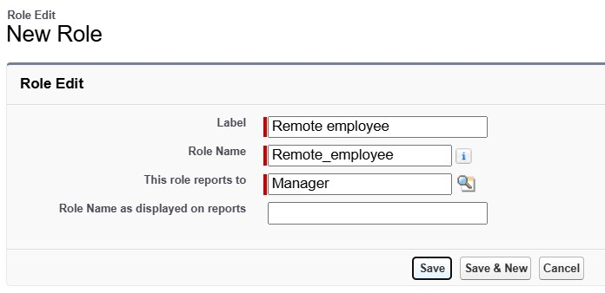

# Milestone 11 - Users

A user is anyone who logs in to Salesforce. Users are employees at your company, such as sales reps, managers, and IT specialists, who need access to the company's records. Every user in Salesforce has a user account. The user account identifies the user, and the user account settings determine what features and records the user can access.

Every user in Salesforce has a user account. The user account identifies the user, and the user account settings determine what features and records the user can access. Each user account contains at least the following:

* Username
* Email Address
* User's First Name (optional)
* User's Last Name
* Alias
* Nickname
* License
* Profile
* Role (optional)

**Use Case:**

TheSmartBridge is all set to move with the Salesforce platform. As this platform is very new to the employees in the organization it’s up to you to enlight every employee in it.

**Activity 1:**

**Create User**

1. Go to setup → type users in quick find box → select users → click New user.
2. Fill in the fields
   1. First Name : Niklaus
   2. Last Name : Mikaelson
   3. Alias : Give a Alias Name
   4. Email id : Give your Personal Email id
   5. Username : Username should be in this form: [text@text.text](mailto:text@text.text)
   6. Nickname : Give a Nickname
   7. Role : HR
   8. User license : Salesforce
   9. Profiles : HR

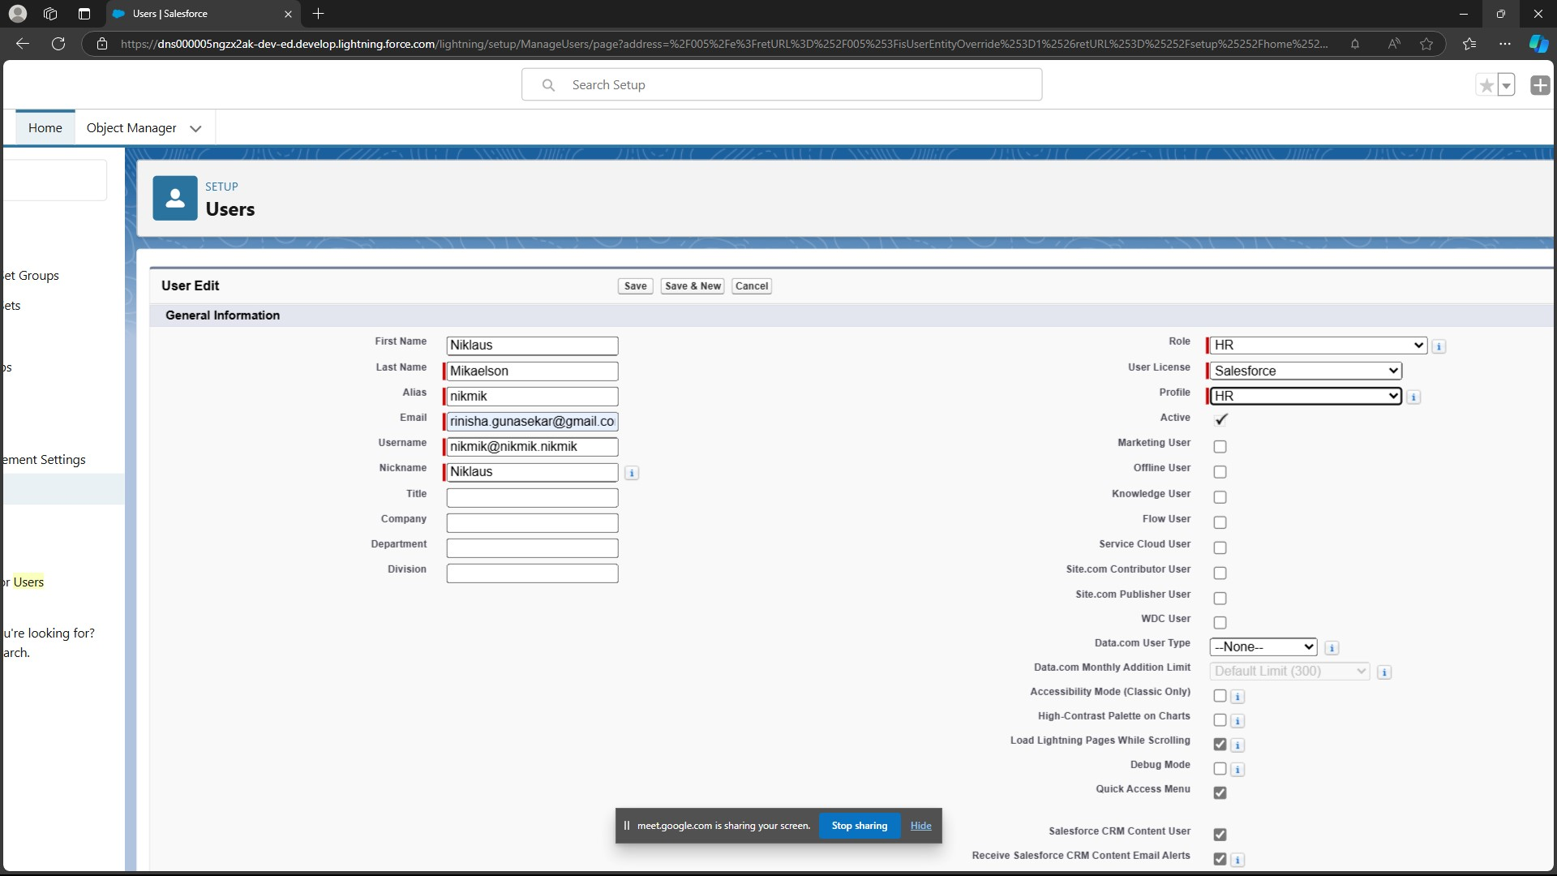

1. Save.

**Activity 2:**

1. Go to setup → type users in quick find box → select users → click New user.
2. Fill in the fields
   * First Name : Kol
   * Last Name : Mikaelson
   * Alias : Give a Alias Name
   * Email id : Give your Personal Email id
   * Username : Username should be in this form: text@text.text
   * Nick Name : Give a Nickname
   * Role : Manager
   * User license : Salesforce Platform
   * Profiles : Manager

● 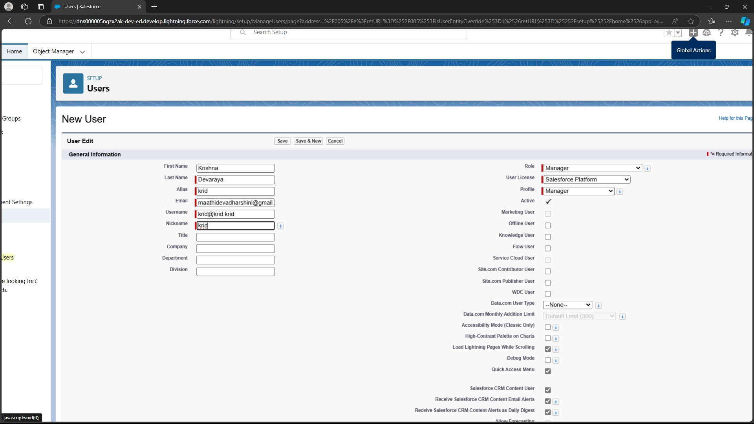

1. Save.

**Activity 3:**

Create two more users as mentioned in activity 2

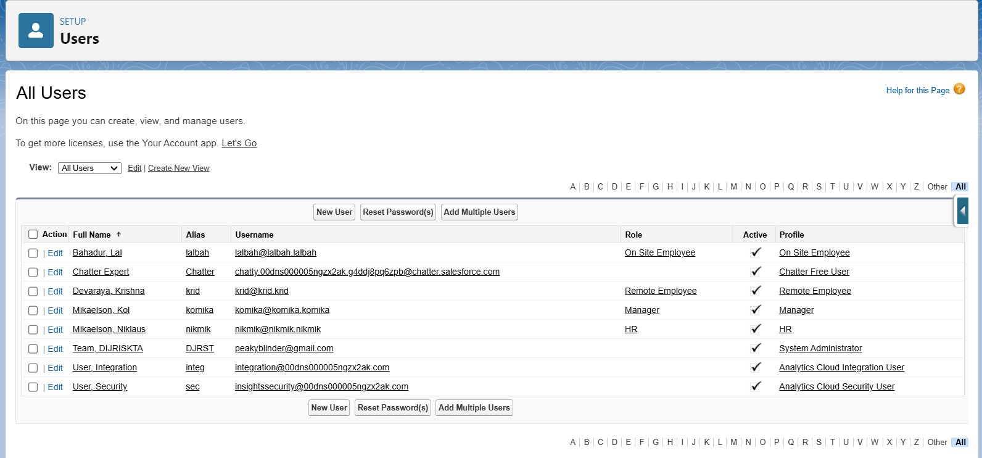

# Milestone 12 - Page layouts

Page Layout in Salesforce allows us to customize the design and organize detail and edit pages of records in Salesforce. Page layouts can be used to control the appearance of fields, related lists, and custom links on standard and custom objects' detail and edit pages.

**Use Case:**

Hurray!! you have completed the data model structure for your organization but while looking at the detailed and edit pages it seems to be so clumsy, so decide to organize the page in a pleasant way for the sake of good and pleasant appearance and assembling all different kinds of information in different sections.

**Activity 1 :**

**To Create a Page layout:**

1. Go to Setup → Click on Object Manager → Search for the object (Employee) → From drop down click on Edit.

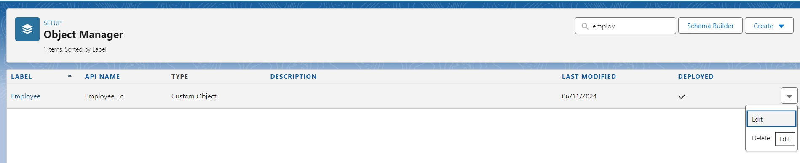

1. Click on Page layout → Click on New.

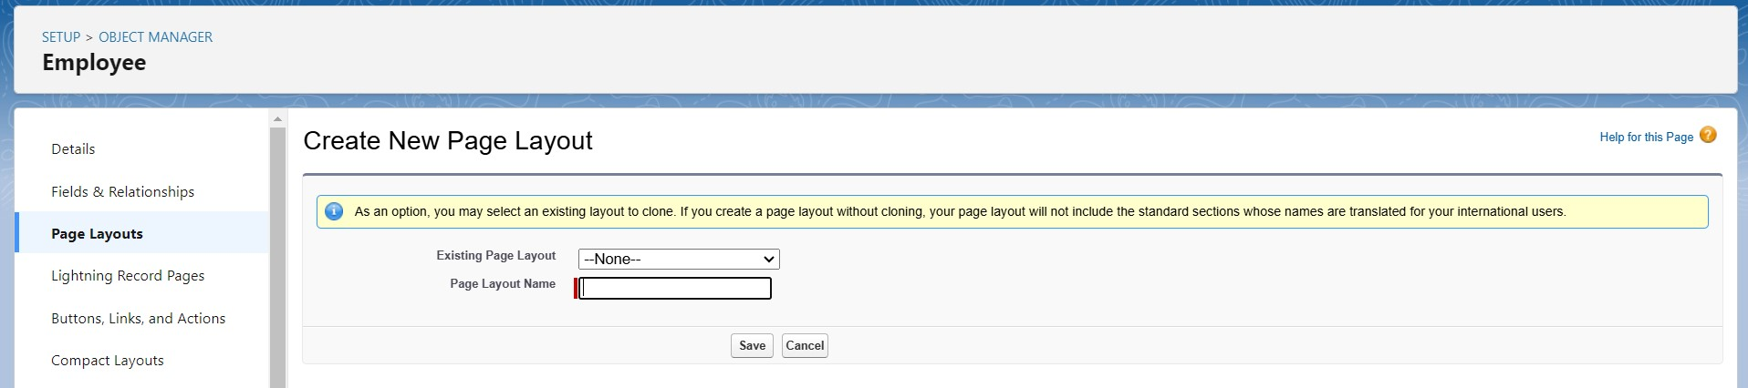

1. Give Page layout Name as “On Site Employee Layout” and click on Save.
2. Drag and drop the Section from the highlight panel below the Information and name it as “Personal Information” and click Ok.
3. Drag Date of Birth, Address and Age fields from Employee Information to Personal Information section.
4. Similarly perform the above step to create “Allowances” and add allowances fields in it as shown below.

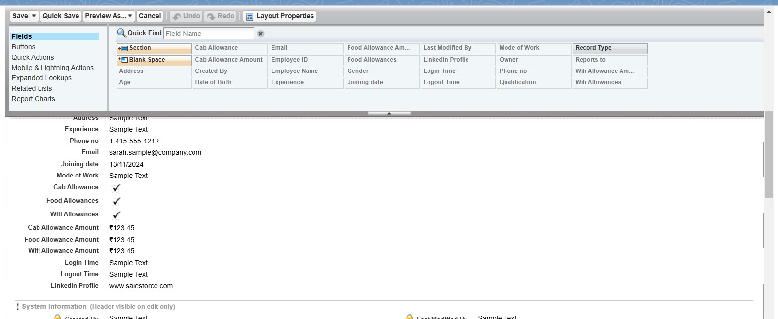

1. Click Save.
2. Make sure your page layout looks like the picture above.

**Activity 2 :**

Create another page layout and name it as “Remote Employee Layout”, and in the allowances section use only Wifi Allowance and Wifi Allowances Amount fields.

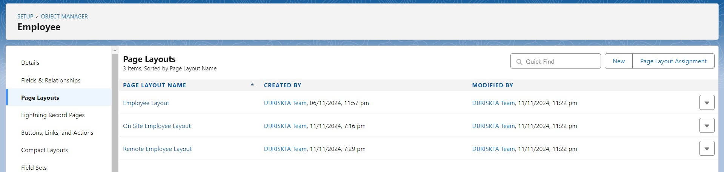

# Milestone 13 - Chatter Group

Salesforce Chatter Groups are collaborative spaces within the Salesforce platform that enable teams to communicate, share information, and collaborate on projects. They provide a centralized hub for discussions, file sharing, and updates, allowing users to stay connected, streamline workflows, and enhance productivity.

**Use Case:**

Congratulations Admin you have made the job done for the organization, Amar The Founder of the organization and Jai Prakash The COO are very impressed with your work. But still there are some updates which your COO wants in your organization. So he comes to you with the idea that all the employees should have a common group for work discussion inside the salesforce. You know how to get this done with your admin skills.

**Activity 1 :**

Creating a chatter group for your organization.

1. Click the App Launcher  .
2. Enter Groups in the Search apps and items... box and select Groups.

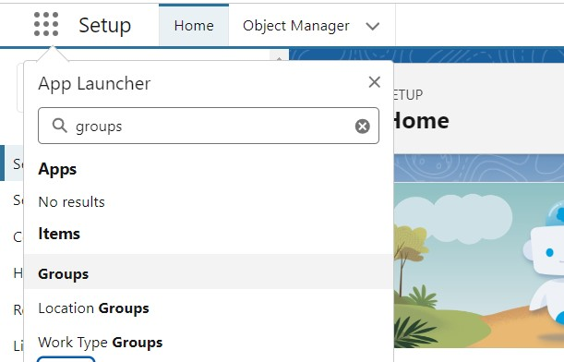

1. Click New.

|  |  |
| --- | --- |
| **Field** | **Value** |
| Group Name  Description  Access Type  Allow Customers | Internal Discussion  Give a understanding Description on your own  Private  Checked |

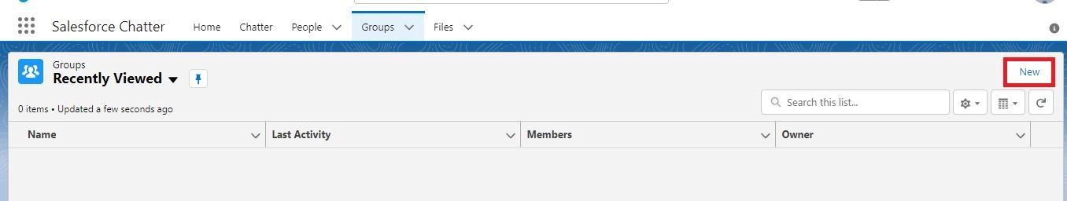

1. Fill in the new group information with these details:

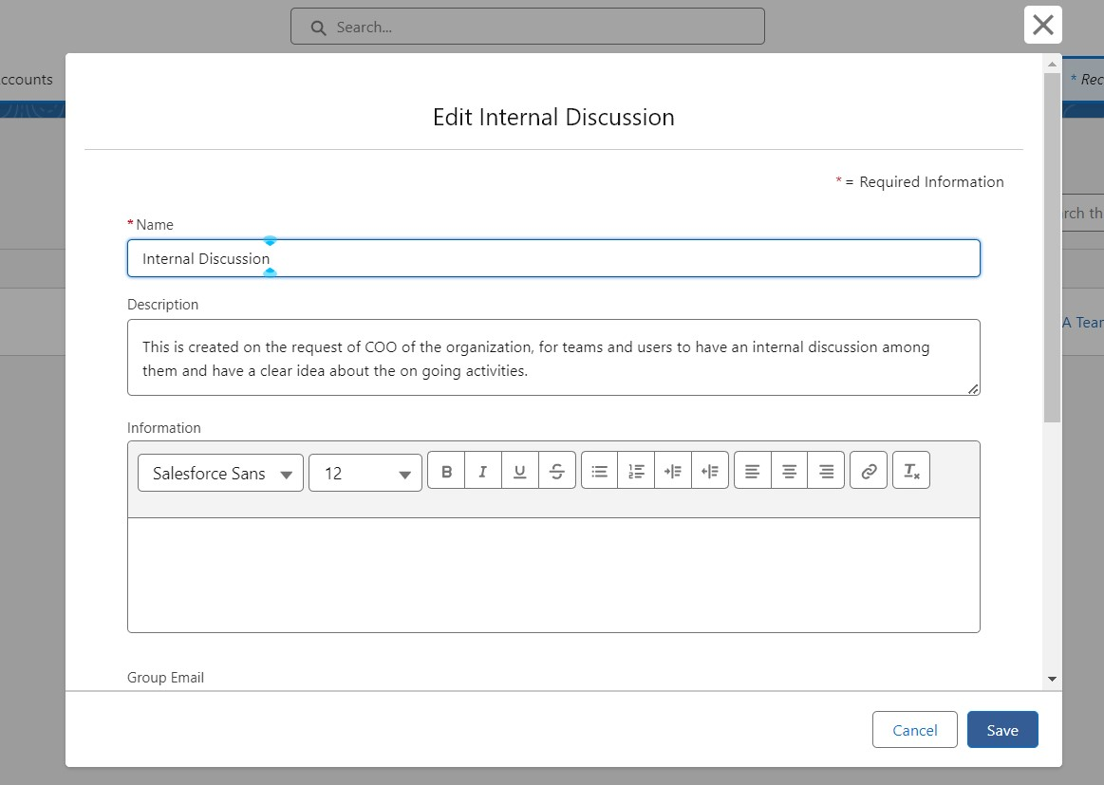

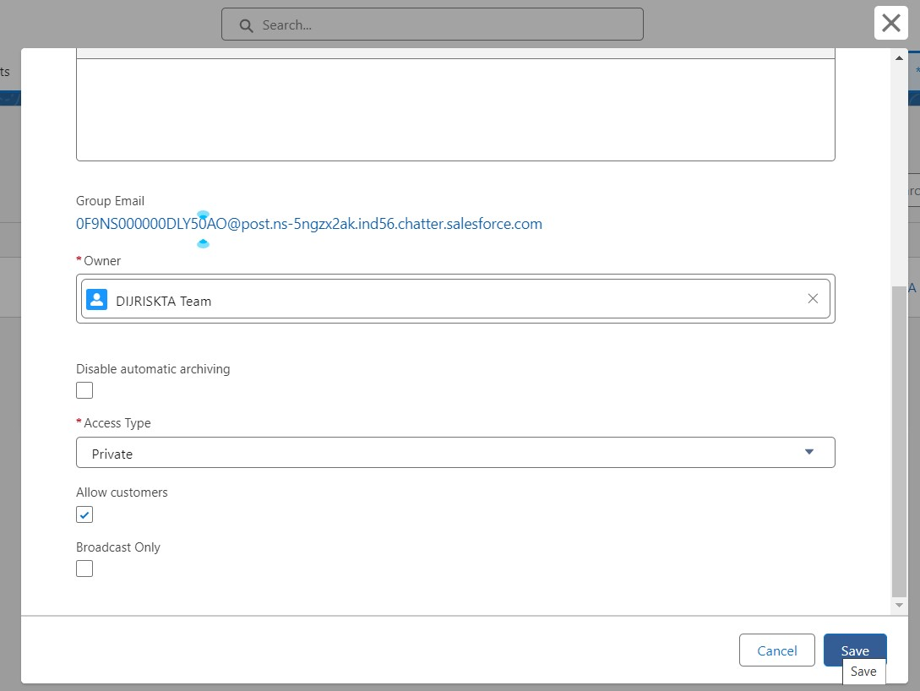

1. Click Save & Next. Skip the Upload Picture section and click Next.
2. On the Manage Members screen, click Add next to users you created in the previous activity.

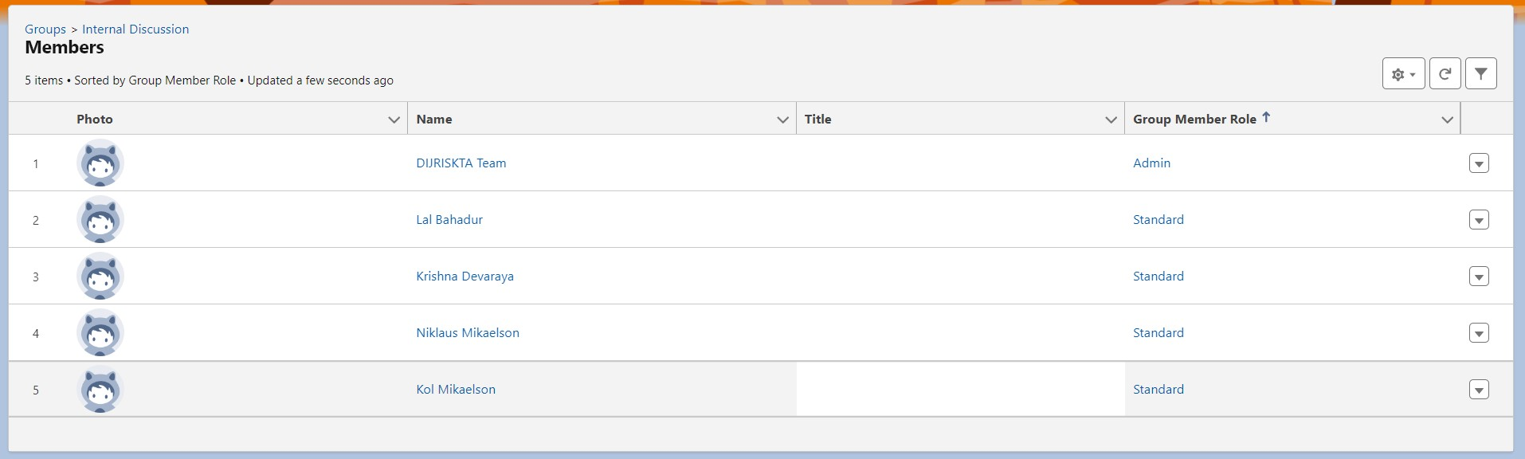

1. Click Done.

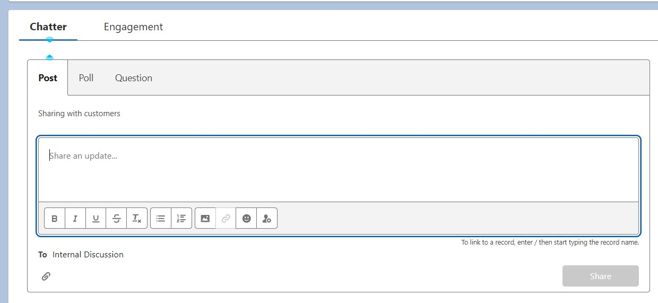

1. This is how your group interface looks like.
2. Where it says Share an update, post this message to the group: Welcome to the Internal Discussion Group, here you can post anything which is related to ongoing projects.
3. Click Share.

Note: You can like or comment on this post.

**Note:** there is a default chatter group in the org with all the active users in it, this activity is to show you how to create a chatter group and add users into it.

# Milestone 14 - Record Types

Record Types are a way of grouping many records of one type for that object. These can be applied to any standard or custom object, and allow you to have a different page layout, fields, required fields, and picklist values. Record types allow administrators to create a different page layout with custom picklist fields and values for the same business process and various business processes.

**Use Case:**

All things done for the organization. But some of the organization employees feel it difficult to fill up all the details while creating an employee record, so Jai Prakash (COO) assigned you a task to create different forms for employee records based on their mode of work. As an Admin, you know how to achieve this.

**Activity 1:**

**To create a Record Type:**

1. Go to Setup → click on Object Manager → Search for the object (Employee) → from drop down click Edit.



1. From the left panel click Record Types → New.

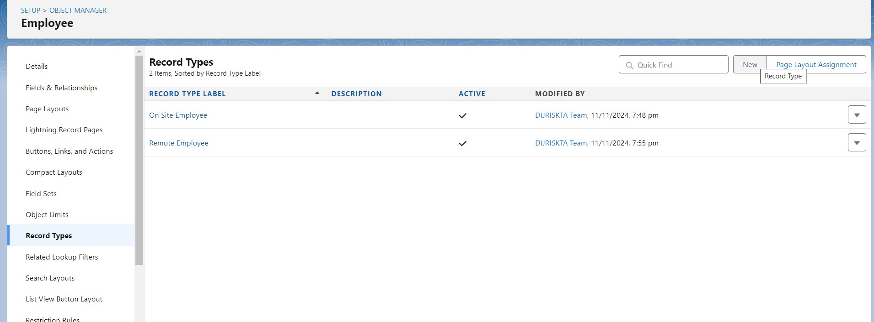

1. Give Record Type Label as “On Site Employee” and make it active.

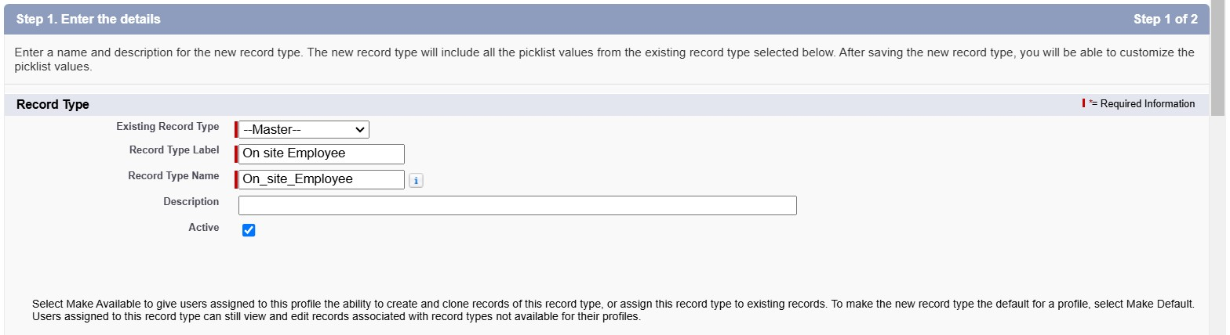

1. Uncheck for “Make Available”.

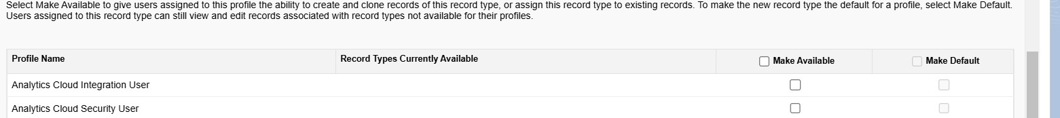

1. Scroll down and check for the Manager & System Administrator profile and click on Next.

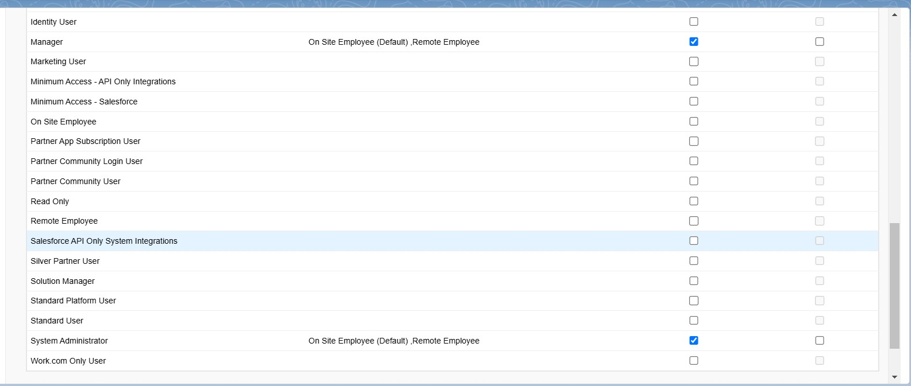

1. Select “Apply a different layout for each profile”, and change page layout to On Site Employee Layout for manager profile and System Administrator.

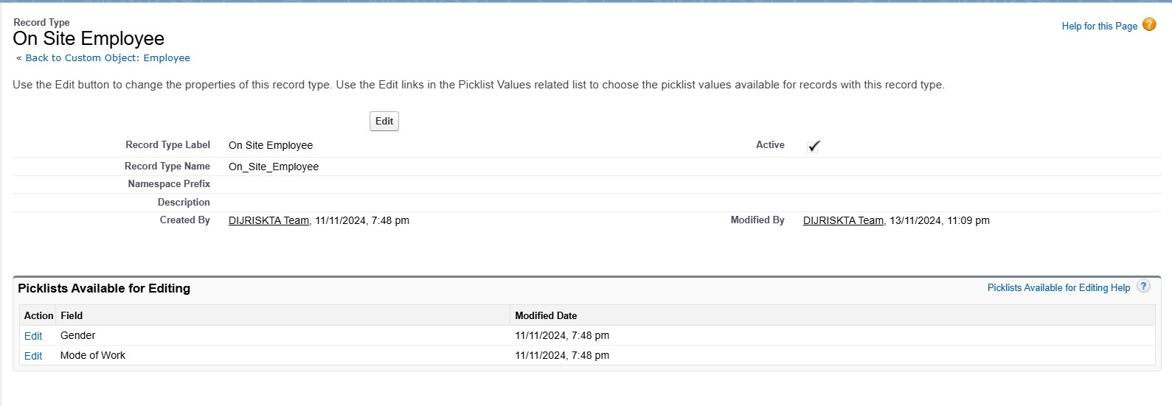

1. click Save.

**Activity 2:**

Create another Record Type with name “Remote Employee” following the step from activity

1.

**Note:** use Remote Employee page layout for Remote Employee record type.

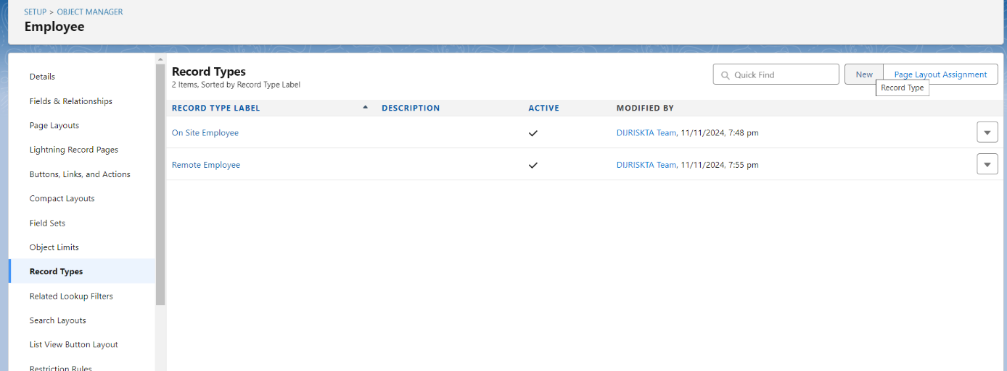

# Milestone 15 - Permission sets

A permission set is a collection of settings and permissions that give users access to various tools and functions. Permission sets extend users' functional access without changing their profiles. Users can have only one profile but, depending on the Salesforce edition, they can have multiple permission sets.

**Use Case:**

Every day is a war for Admin with some unique challenges. A new challenge awaits as you enter the office. After you arrive in office you came to know that the manger is on leave and there’s a lot work pending at his desk generally there are numbers of employee records that the manager have to enter in the salesforce org and no other person have the permission to create those records except him and your CEO wants it to be done by the end of the day, as it’s not possible to create the same profile and assigned it to some other person in the org. So using your admin knowledge you came up with the idea to create a permission set and assign it to someone who doesn’t have the access to do that job.

Let’s create a permission set.

**Activity 1:**

1. Go to setup → type “permission sets” in quick search → select permission sets → New.

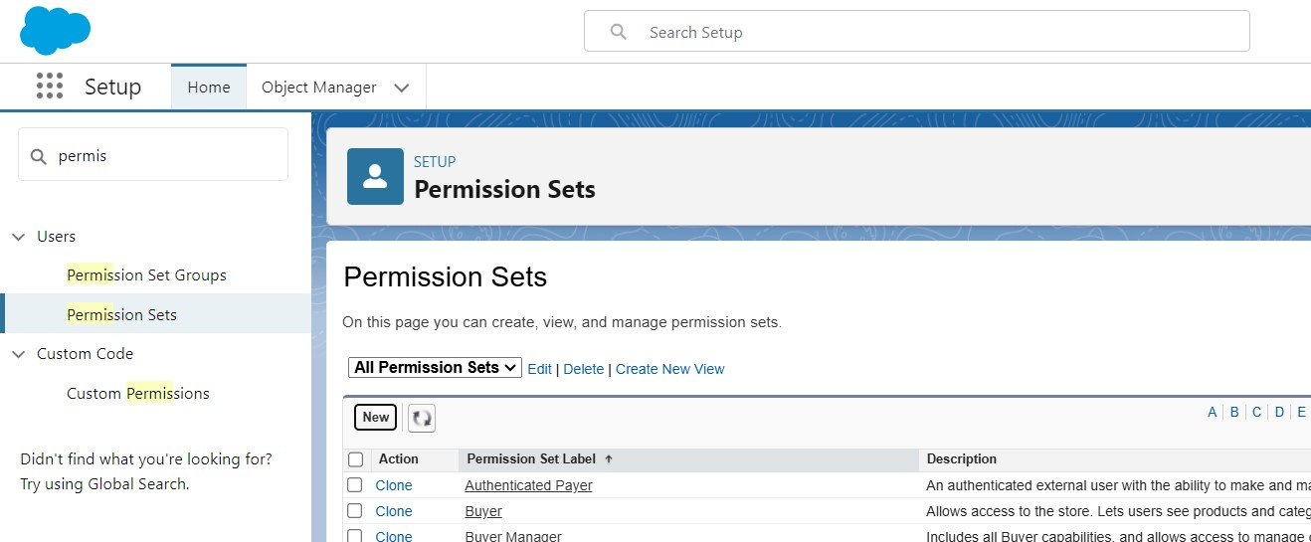

1. Enter the label name as “Per to Emp” → save.

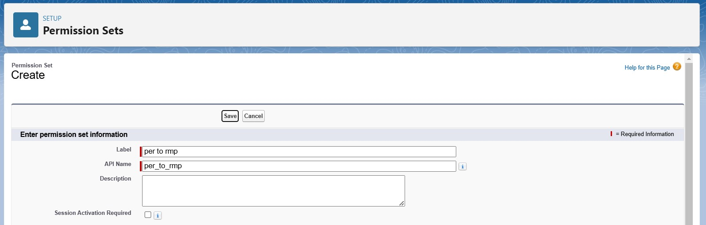

1. Under Apps Select object settings.

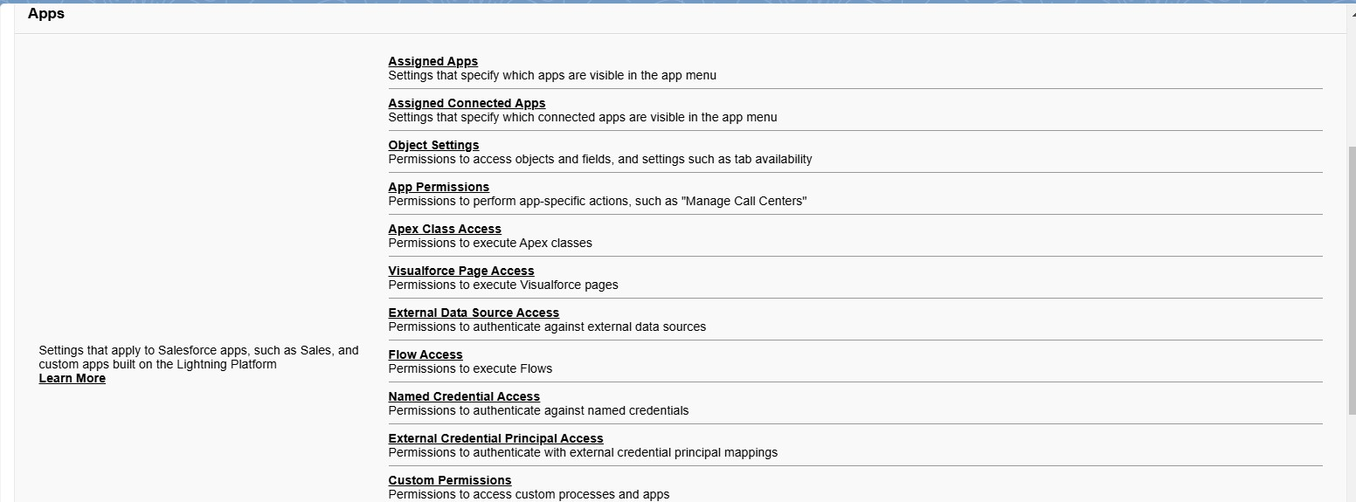

1. Click on Employee object → click on Edit → under object permission check for read and create.

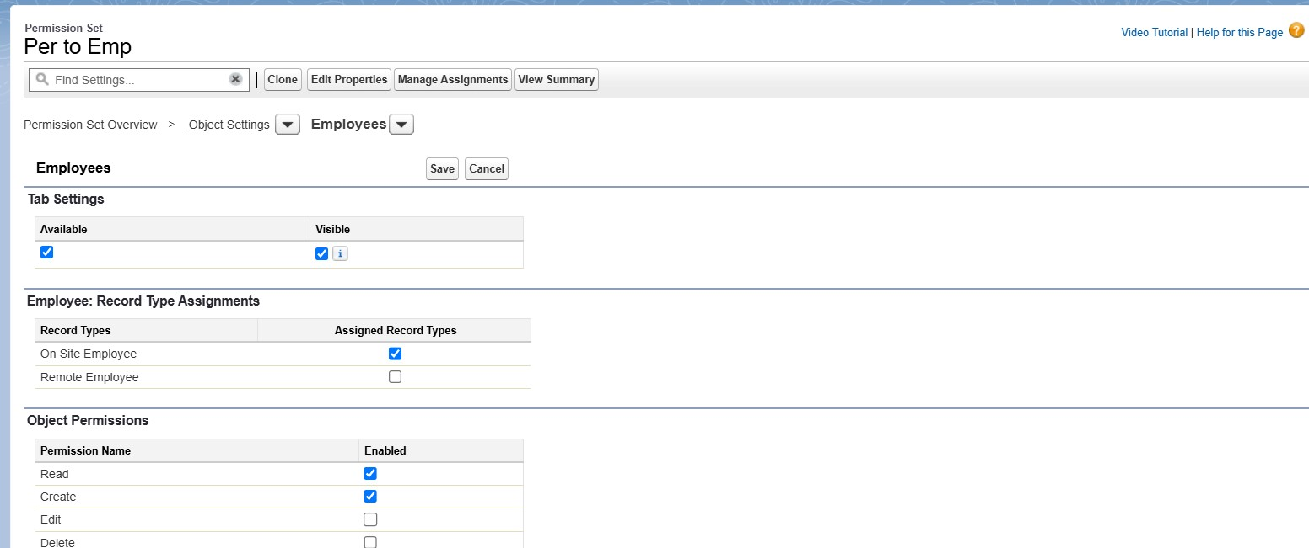

1. Click on Save.
2. After saving the permission click on the Manage assignment

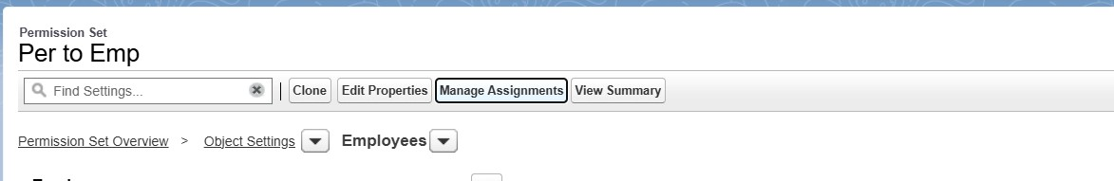

1. Now click on the Manage Assignment.

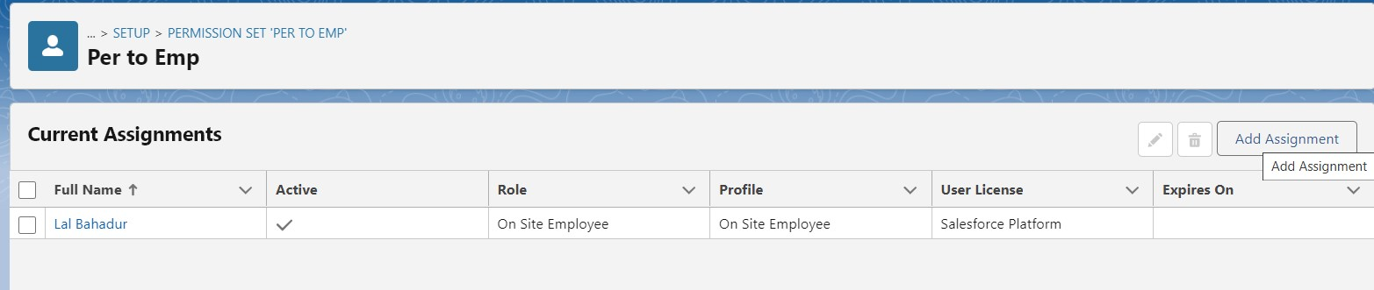

1. Click on Add Assignment.

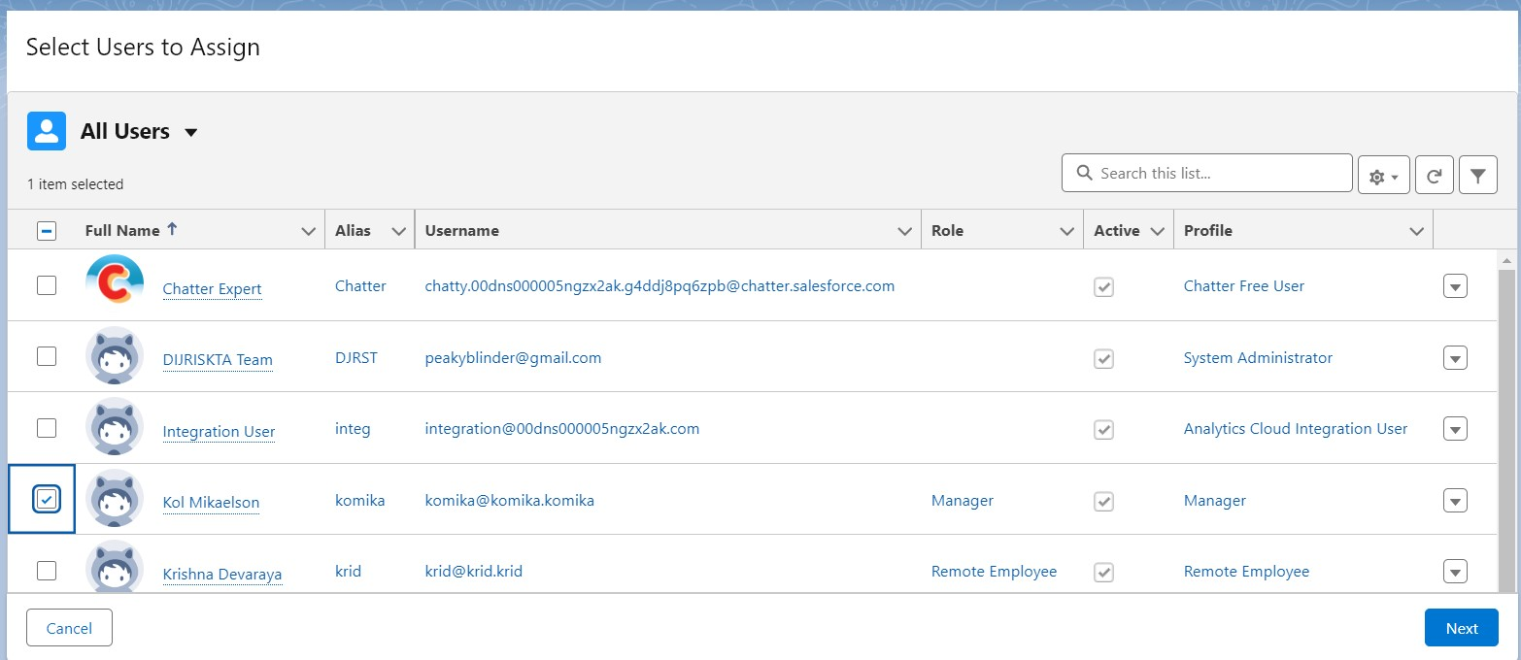

1. Now select the users (any one user with the profile “On Site Employee”) and click on Next.
2. Click on Assign
3. Click on Done.

# Milestone 16 - Reports

Reports give you access to your Salesforce data. You can examine your Salesforce data in almost infinite combinations, display it in easy-to-understand formats, and share the resulting insights with others. Before building, reading, and sharing reports, review these reporting basics.

Types of Reports in Salesforce

1. Tabular
2. Summary
3. Matrix 4.
4. Joined Reports

**Use Case:**

The CEO of an organization wants to have a brief data on employees working, projects in take, project progress, Assets assigned, what are the conditions of the Assets assigned. So he can have a clear picture of his organization and be able to make any decisions required based on this data. So he calls you on this task and wants you to represent the data in an appropriate way.

Let’s create a Report.

**Activity 1:**

**Create Report**

1. Go to the app → click on the reports tab 2. Click New Report.

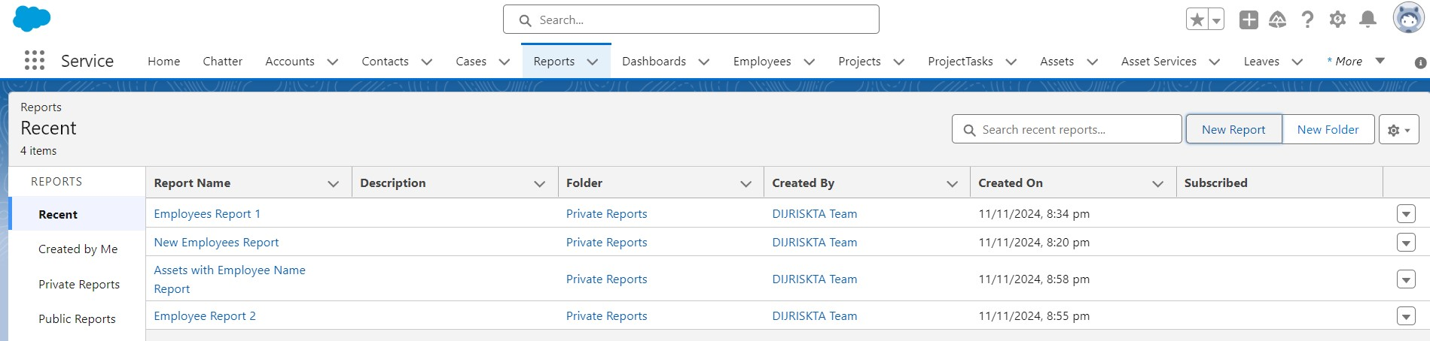

1. Select report type from category or from report type panel or from search panel → click on start report.

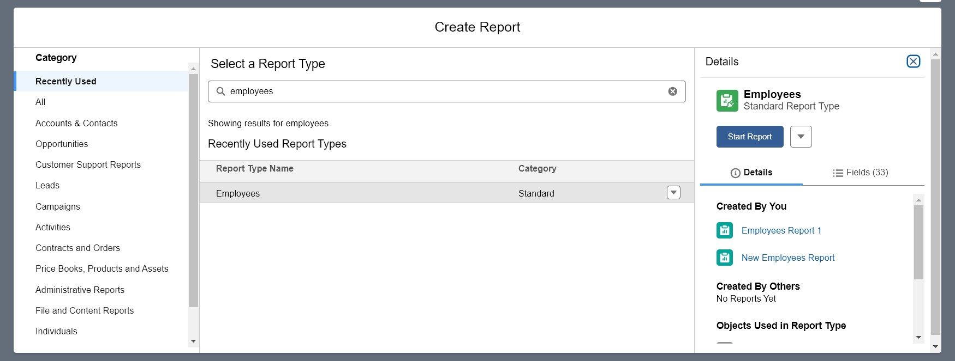

1. Customize your report

● Add fields from left pane as shown below

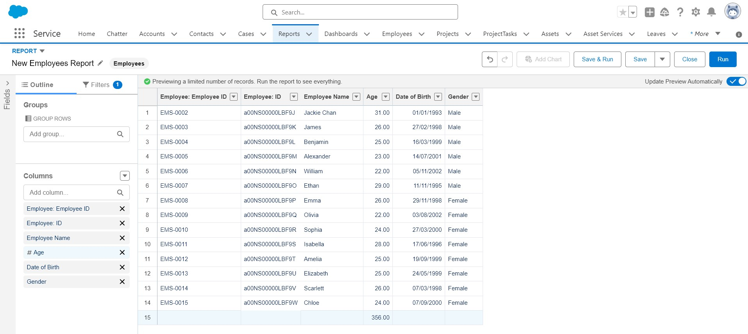

1. Save or run it.

**Note:** Reports may get varied from the above pictures as the data might be different.

**Activity 2:**

1. Create a report with report type: “Employees with ProjectTasks and Projects”.
2. Create a report with report type: “Employees with Assets”.

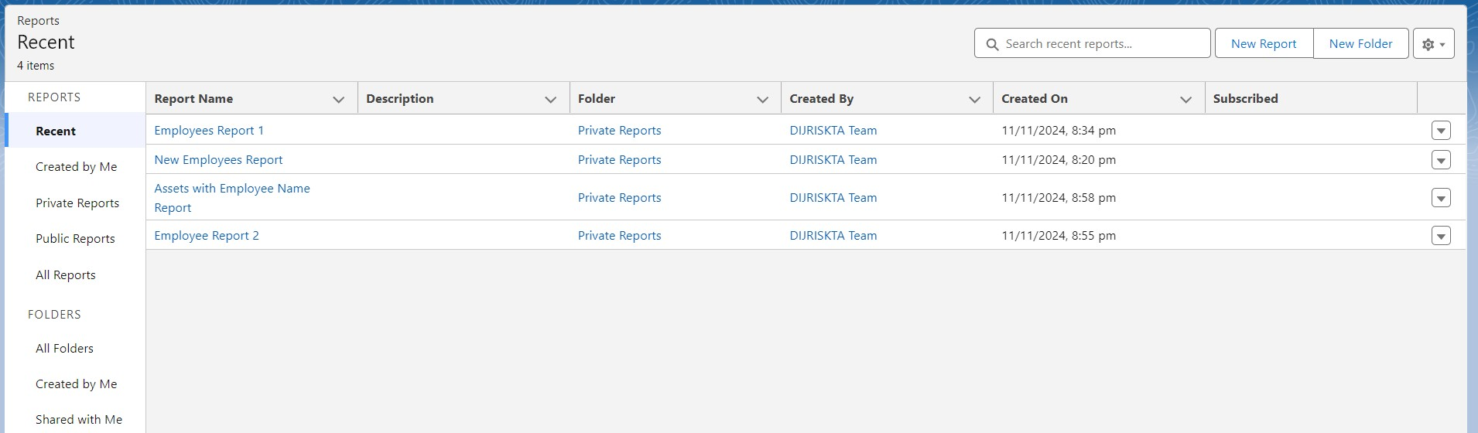

# Milestone 17 - Dashboards

Dashboards help you visually understand changing business conditions so you can make decisions based on the real-time data you’ve gathered with reports. Use dashboards to help users identify trends, sort out quantities, and measure the impact of their activities. Before building, reading, and sharing dashboards, review these dashboard basics.

**Use Case:**

As an Admin for the organization you keep pushing yourself to reach out the business requirements to take the organization to peak heights and all your superiors are very much impressed with your efforts and work dedication. In addition with reports you make an ease for the CEO in viewing the reports with data visualization. So he doesn't have to search for the data he wants during the meetings.

**Activity 1:**

**Create Dashboard**

1. Go to the app → click on the Dashboards tabs.

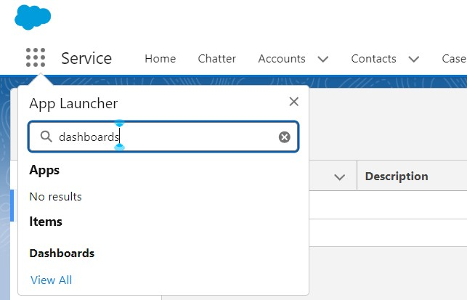

1. Give a Name and click on Create.

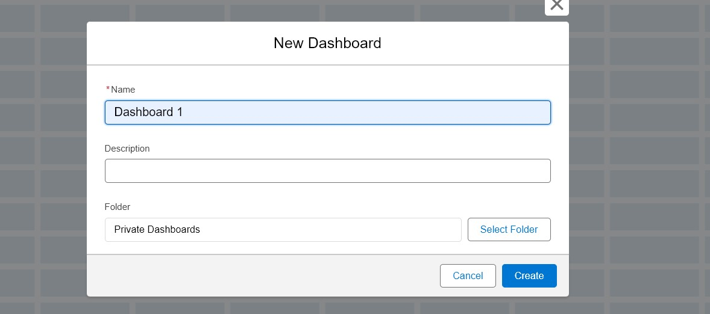

1. Select add component.



1. Select a Report and click on select.

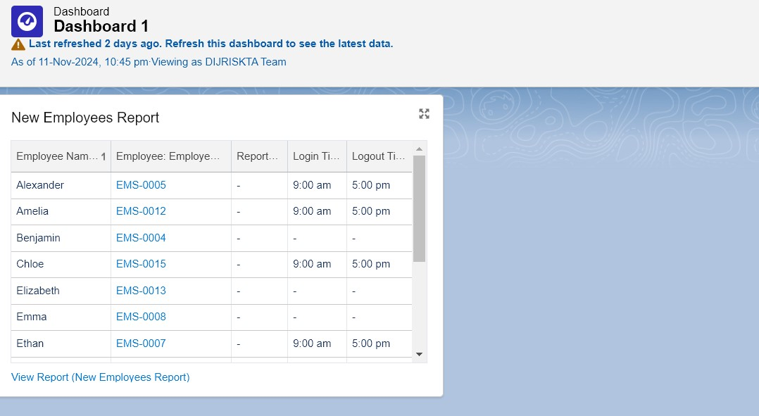

1. Click Add then click on Save and then click on Done.

**Activity 2:**

Create another Dashboard as we discussed in activity 1.

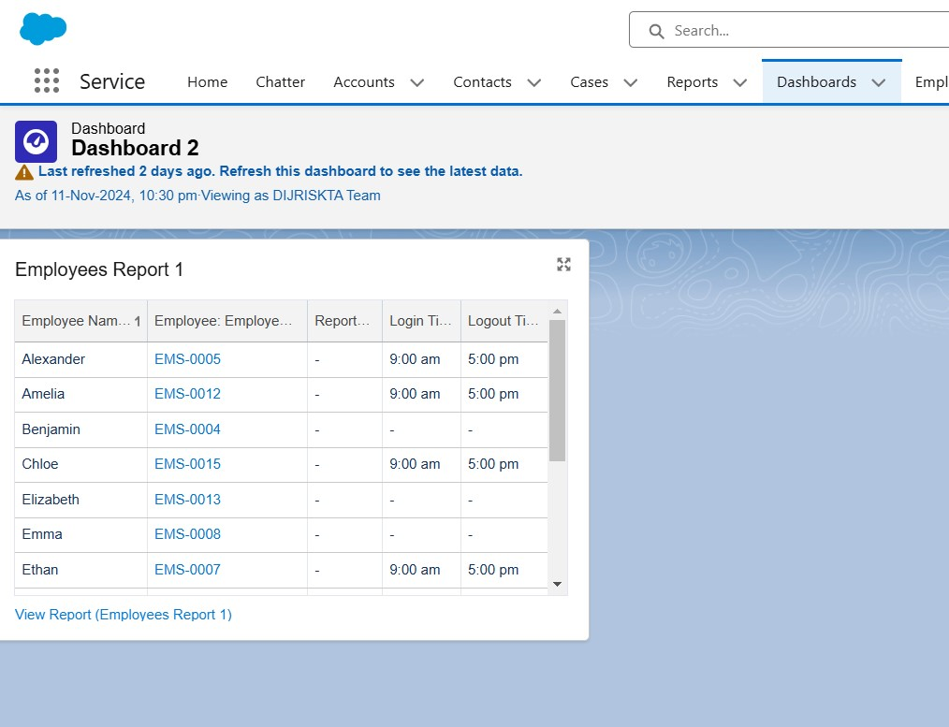

# Milestone 18 - Approval Process

**Use Case:**

The Hiring Manager (HR) at TheSmartBridge wants to track the leave applications for each and every employee of the company. His requirement is the no leave application with more than 5 days of leave should come to him but automatically get submitted to the Employee Manager. If the leave application is more than 5 days then only his approval is needed.

As an Admin to TheSmartBridge you know what to do in order to achieve this requirement.

**Prerequisites:**

Create the **leave** object with the following fields.

|  |  |  |  |
| --- | --- | --- | --- |
| **Object** | **Fields** | **Datatype** | |
| Leave | Employee Name  No. of Days  Subject  Description  Status | Lookup with Employee object  Number  Text  Text Area(Rich)  Picklist: values as follows | |
| Submitted  Approved  Rejected |  |
| **Note:** Make sure the Status field is read only for everyone. (Give read only permission in step 3 while creating the field) |

Create the tab for the **leave** object.

**Activity 1:**

**Create an Approval Process for Leave object.**

1. Go to Setup → type Approval Processes in quick find → click on Approval Processes.

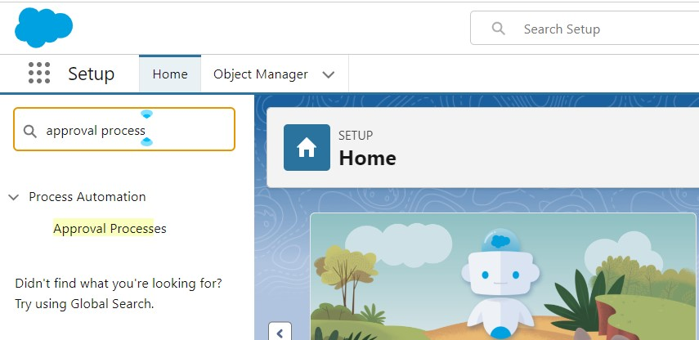

1. In the Manage Approval Processes For list, select Leave.
2. Click Create New Approval Process and select Use Jump Start Wizard.

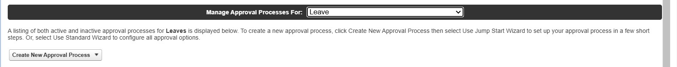

1. Enter the following parameters

|  |  |
| --- | --- |
| Parameter | Value |
| Name | Leave Approval Request |
| Unique Name | Leave_Approval_Request(This automatically gets sent when you tab out of the Name field) |
| Approval Assignment Email Template | Leave blank |
| Add the Submit for Approval button and  Approval History related list to all Travel  Approval page layouts | Leave this selected/checked |
| Use Approver Field of Leave Owner | Leave unselected/unchecked. |
| Select Approver | select Automatically assign to approver(s) and for users select the name of the user with the Manager role. |

1. Click Save.
2. Click View Approval Process Detail Page.

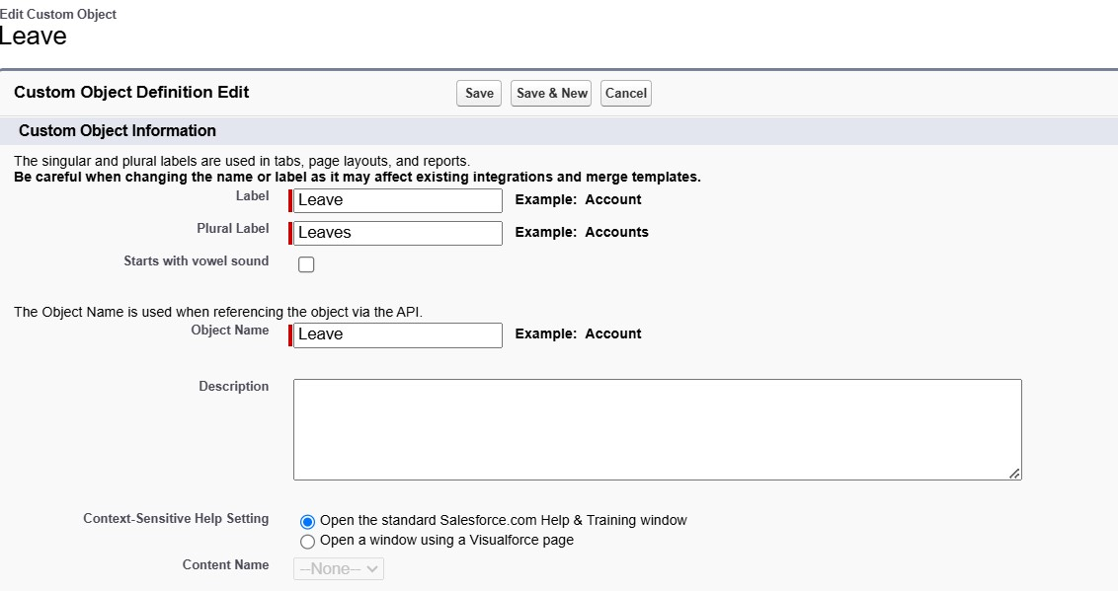

**Activity 2:**

**Initial Submission Action:**

1. Under initial submission action click on add new and then select field update.
2. Give name as “Approval Status to Submitted”.

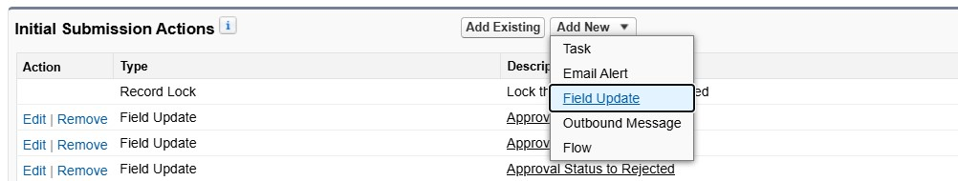

1. Select Status for the field to update.
2. Under specify new field value select “A specific value” and select submitted and click Save.

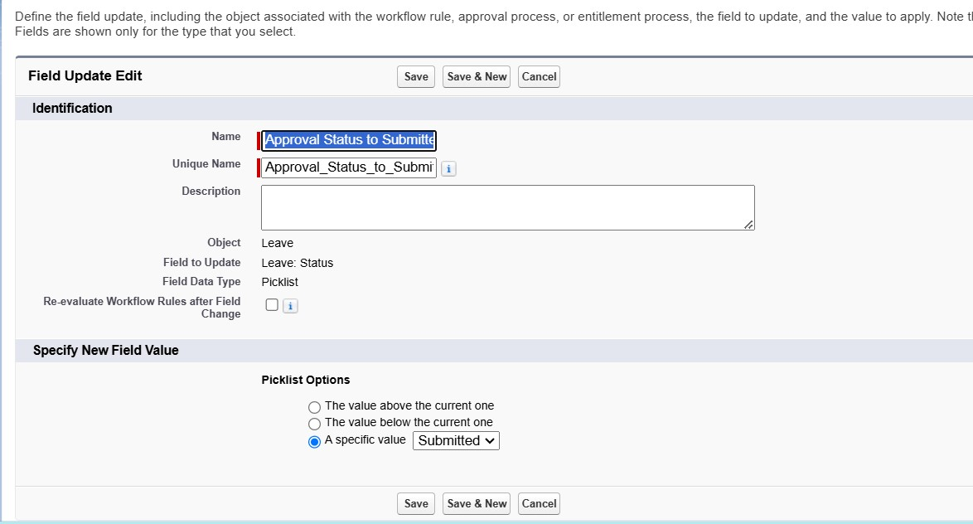

**Activity 3:**

**Approval Steps:**

1. While you are still on Leave Approval Request detail page, Under approval steps click the new approval step.
2. Give the name as “Approval from HR” and click on next.

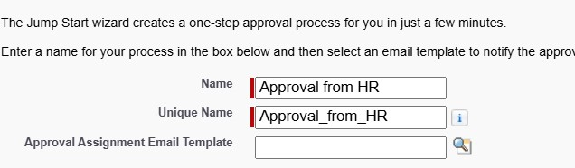

1. Under specify step criteria select “Enter this step if the following (Criteria are met)”,

Select field : “Leave: No. of Days”,

Operator : equals Value : 5

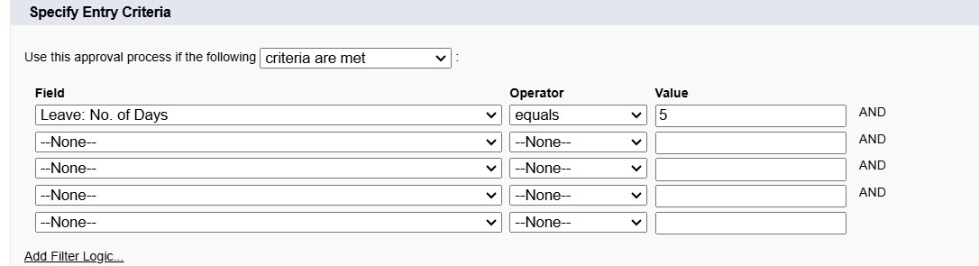

1. Click next.
2. Under select approver : select Automatically assign to approver(s) and for users select the name of the user with the HR role.

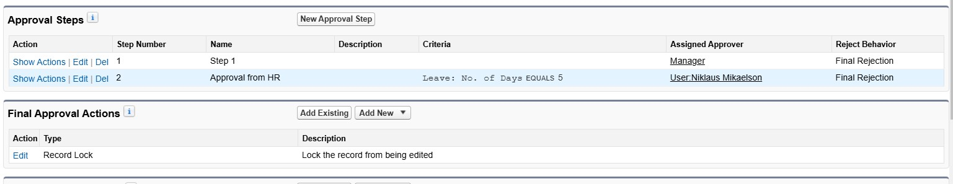

1. Click on Save.
2. No, I'll do this later. Take me to the approval process detail page to review what I've just created and click Go.

**Activity 4:**

**Final Approval Action:**

1. Under initial submission action click on add new and then select field update.



1. Give name as “Approval Status to Approved”.

Select Status for the field to update.

Under specify new field value select “A specific value” and select Approved and click Save.

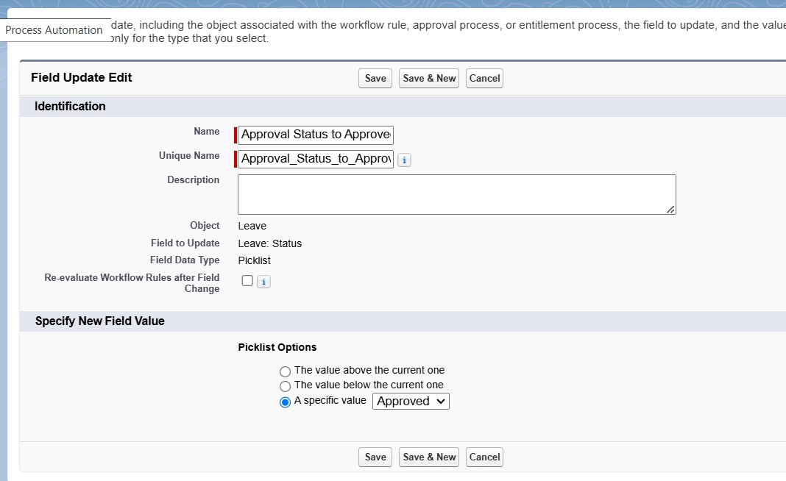

**Activity 5:**

**Final Rejection Action:**

1. Under initial submission action click on add new and then select field update.



1. Give name as “Approval Status to Rejected”.

Select Status for the field to update.

Under specify new field value select “A specific value” and select Rejected and click Save.

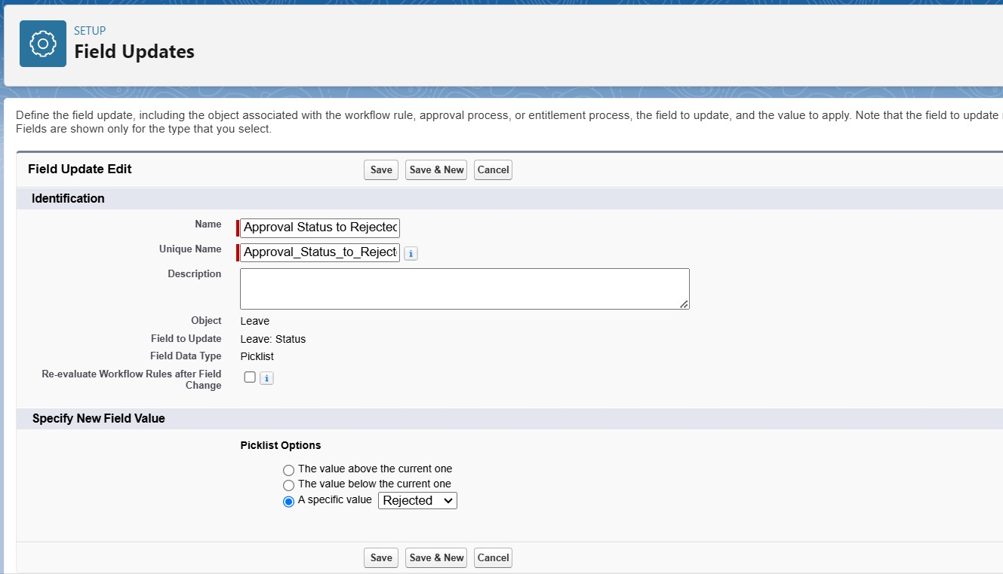

# Milestone 19 - Apex Trigger

**Use Case:**

The Manager at TheSmartBridge wants no duplicate names of employees should enter into the database. So he/she recalls you for the solution.Write a code to achieve this requirement using Salesforce developer skills to fulfill the Managers requirement.

**Activity 1 : Create an Apex Trigger**

1. To create a new Apex Class follow the below steps: Click on the file → New → Apex Class.

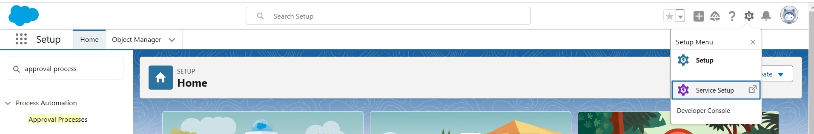

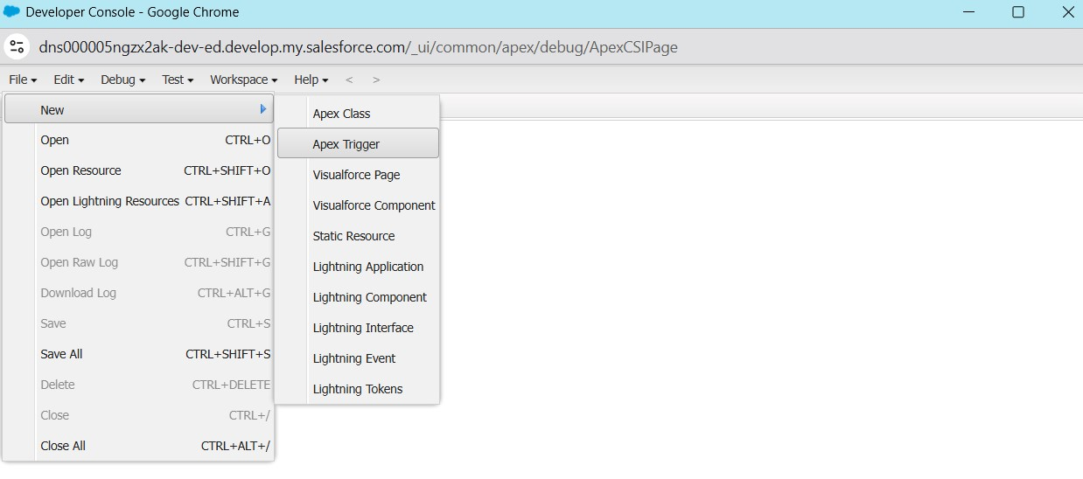

1. Give the Apex Trigger name as “EmpInsert”, and select Employee__c” from the dropdown for sObject.

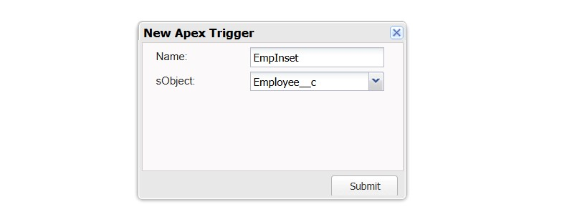

1. Click Submit.
2. Now write the code logic here

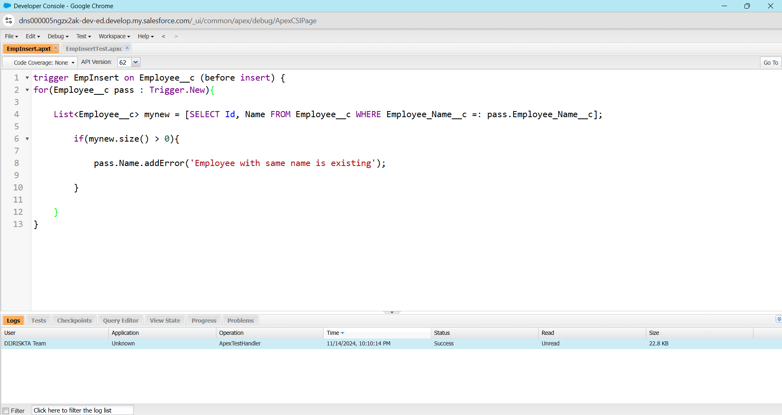

1. Save the code.(click on file → Save)

**Trigger Code:**

trigger EmpInsert on Employee__c (before insert) { for(Employee__c pass : Trigger.New){

List<Employee__c> mynew = [SELECT Id, Name FROM Employee__c WHERE

Employee_Name__c =: pass.Employee_Name__c]; if(mynew.size() > 0){

pass.Name.addError('Employee with same name is existing'); }

}

}

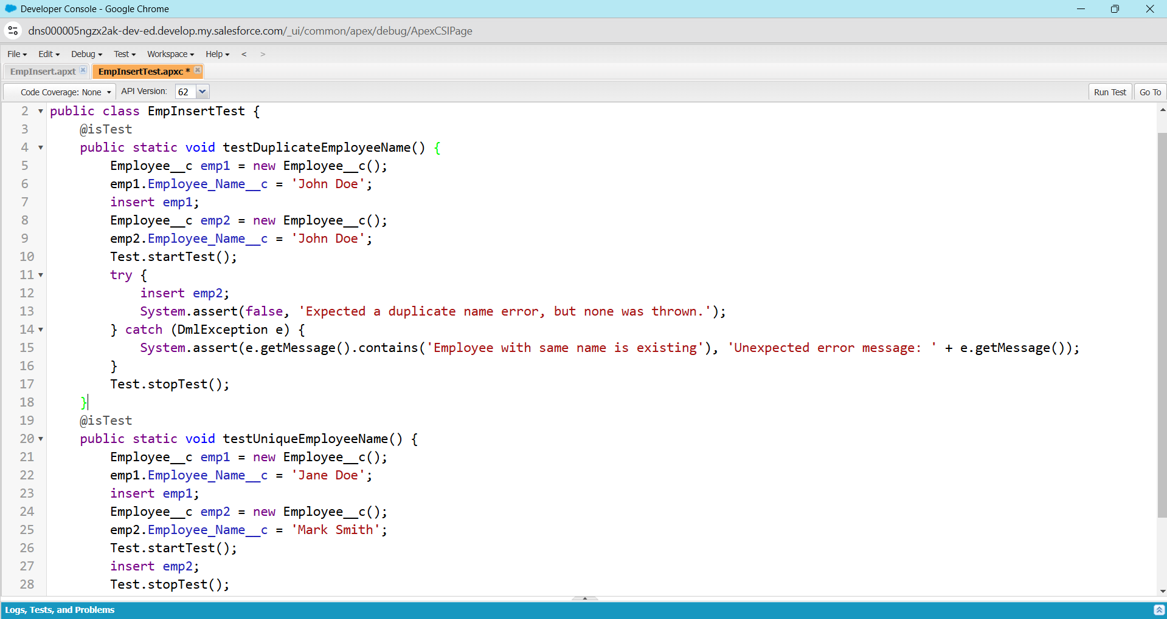

**Trigger Tester Code:**

@isTest

public class EmpInsertTest {

@isTest

public static void testDuplicateEmployeeName() {

Employee__c emp1 = new Employee__c();

emp1.Employee_Name__c = 'John Doe';

insert emp1;

Employee__c emp2 = new Employee__c();

emp2.Employee_Name__c = 'John Doe';

Test.startTest();

try {

insert emp2;

System.assert(false, 'Expected a duplicate name error, but none was thrown.');

} catch (DmlException e) {

System.assert(e.getMessage().contains('Employee with same name is existing'), 'Unexpected error message: ' + e.getMessage());

}

Test.stopTest();

}

@isTest

public static void testUniqueEmployeeName() {

Employee__c emp1 = new Employee__c();

emp1.Employee_Name__c = 'Jane Doe';

insert emp1;

Employee__c emp2 = new Employee__c();

emp2.Employee_Name__c = 'Mark Smith';

Test.startTest();

insert emp2;

Test.stopTest();

List<Employee__c> employees = [SELECT Id, Employee_Name__c FROM Employee__c WHERE Employee_Name__c IN ('Jane Doe', 'Mark Smith')];

System.assertEquals(2, employees.size(), 'Expected 2 employees to be inserted.');}}

**Activity 2 : Testing the Trigger**

Follow the steps which are mentioned in **Milestone 7, Activity 1** and try to create a record with the existing Employee Name say “Jackie Chan” you’ll face the error while saving the record saying “Employee with same name is existing”.

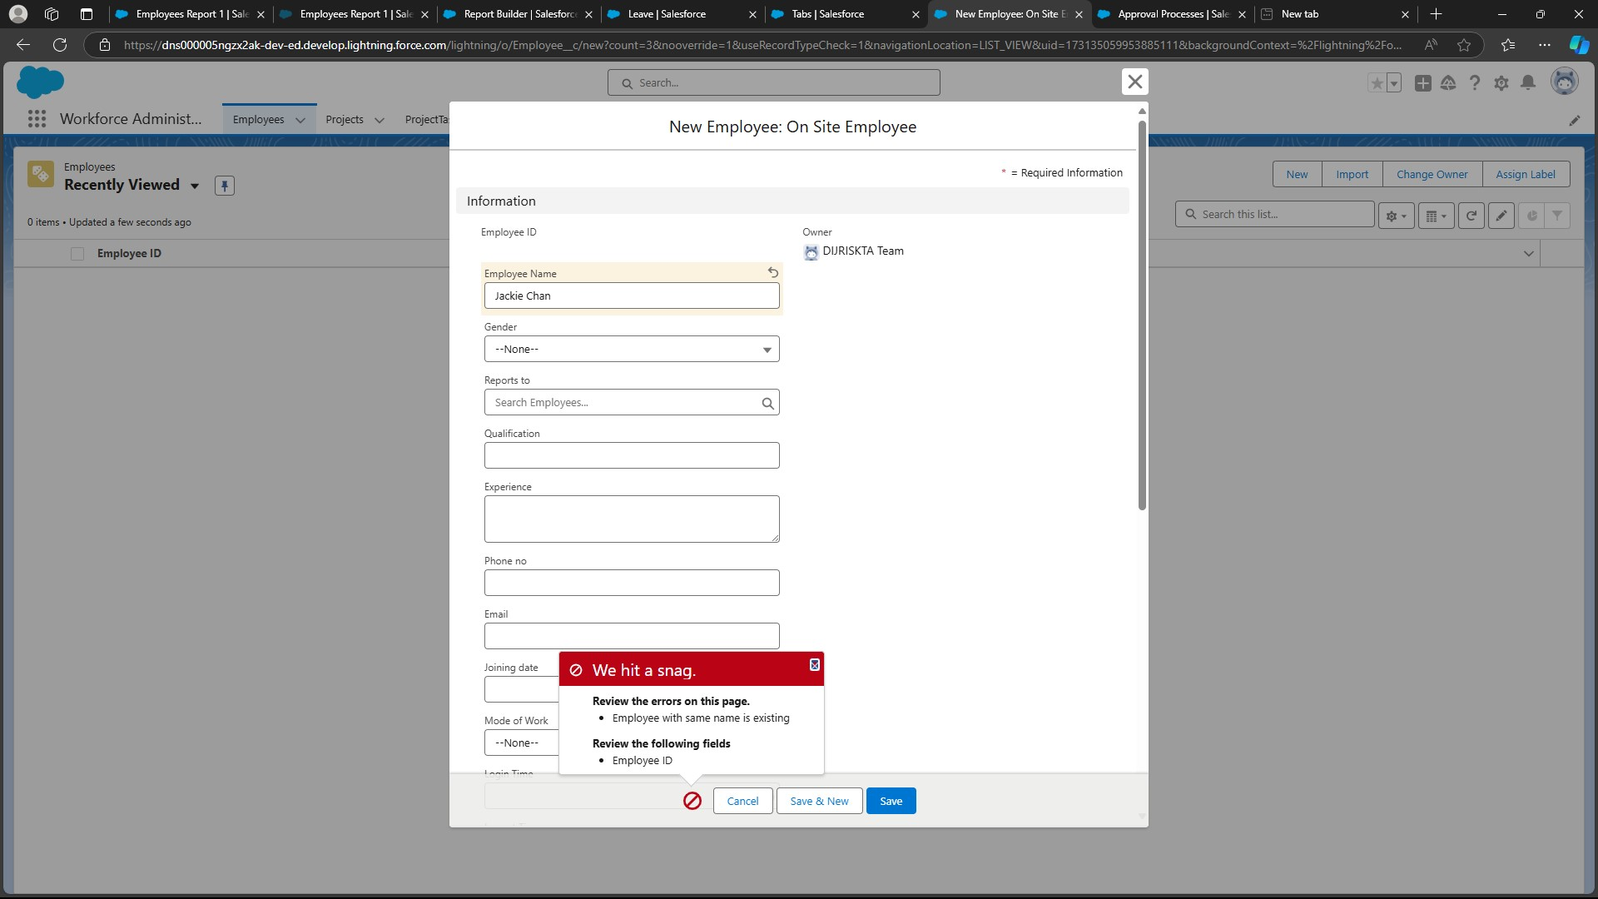

Conclusion:  
In summary, the **Workforce Administration Solution** is designed to centralize and streamline employee management, project tracking, and asset assignment processes within companies. By automating administrative tasks and enhancing data security through Salesforce, it improves efficiency, supports better decision-making, and ensures compliance. This solution enables companies to monitor performance, optimize resource allocation, and maintain accurate, accessible records, ultimately driving productivity and operational effectiveness.